Correlation structure of covariates in virtual populations
Done – N=300, 80,40
Method:
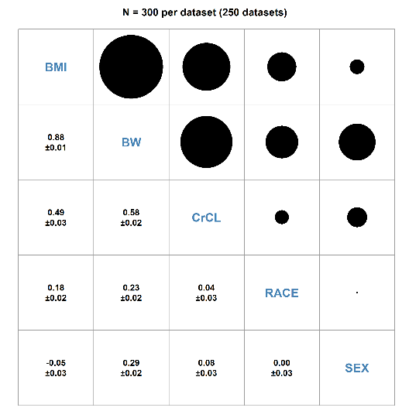
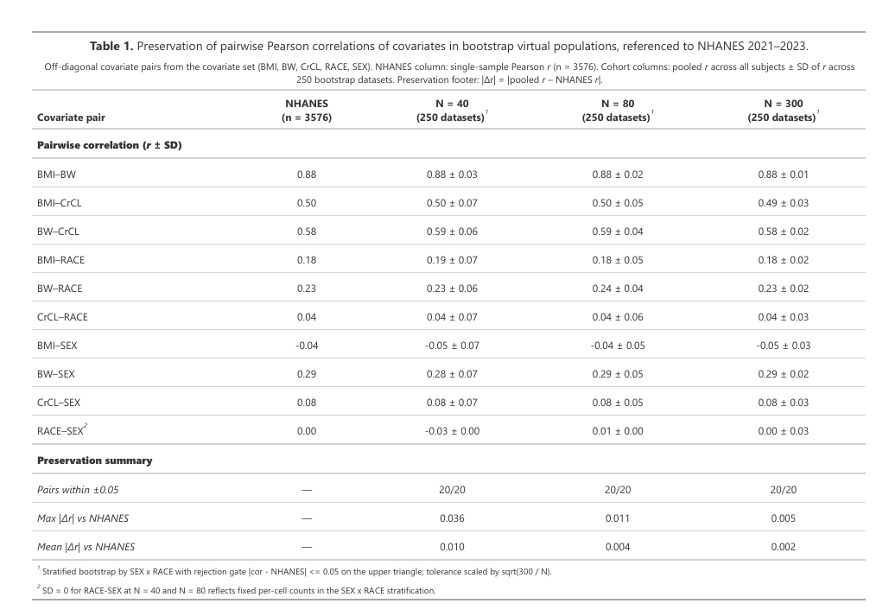

How different methods in the nlmixr2 ecosystem select covariates for popPK models.
Methods status:

Focei-bobyqa

Fit the true models
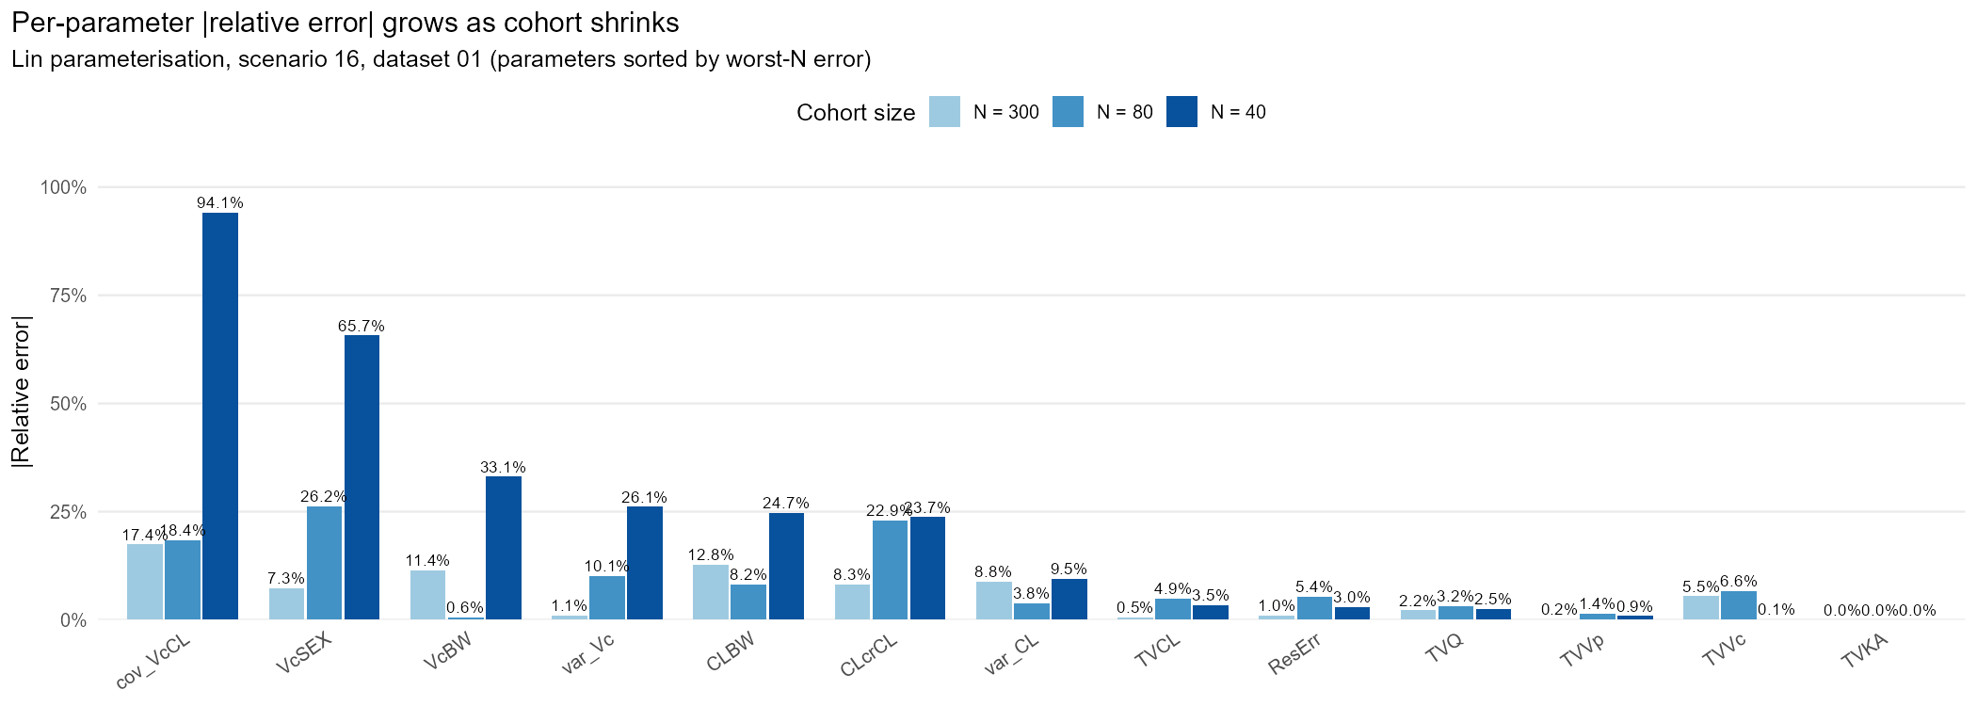

scm _focei_bobyqa

I wonder, if we turn profileoff with the winner selection fixed, whether this will be beneficial ???? Run a pilot test.
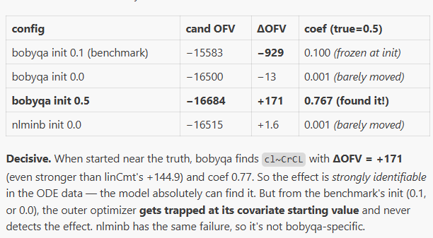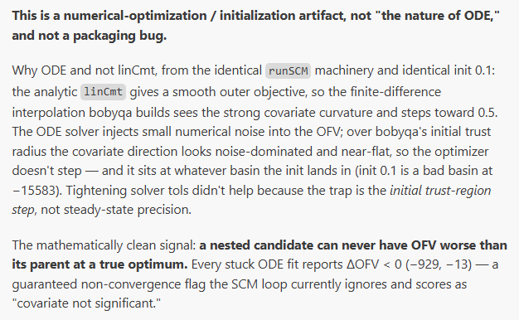
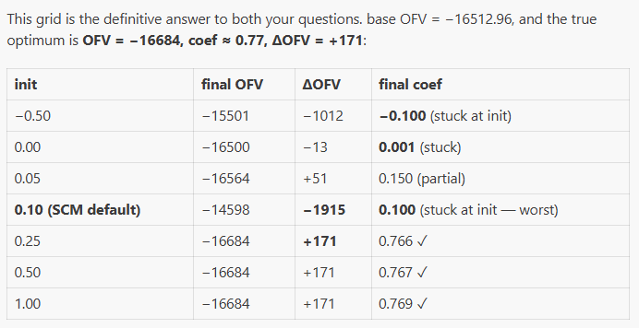
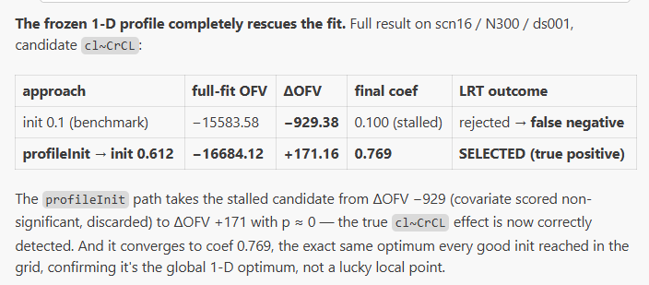
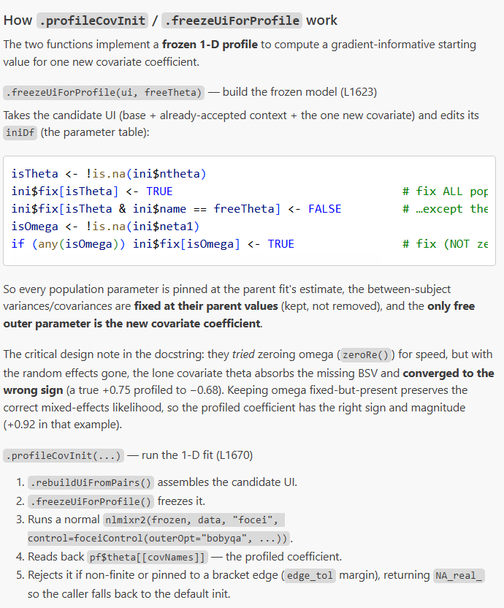
-------------------------------------------Current Retry Machinery----------------------------
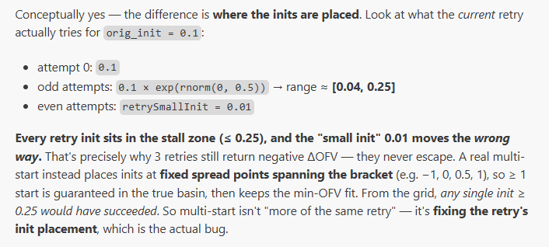
-------------------------------------------------------------------------
Another failure mode: winner selection becomes random when p-value ties
Found the winner rule: bestIdx <- which.min(resTable$pchisqr) — winner is the smallest p-value, not largest dOFV.
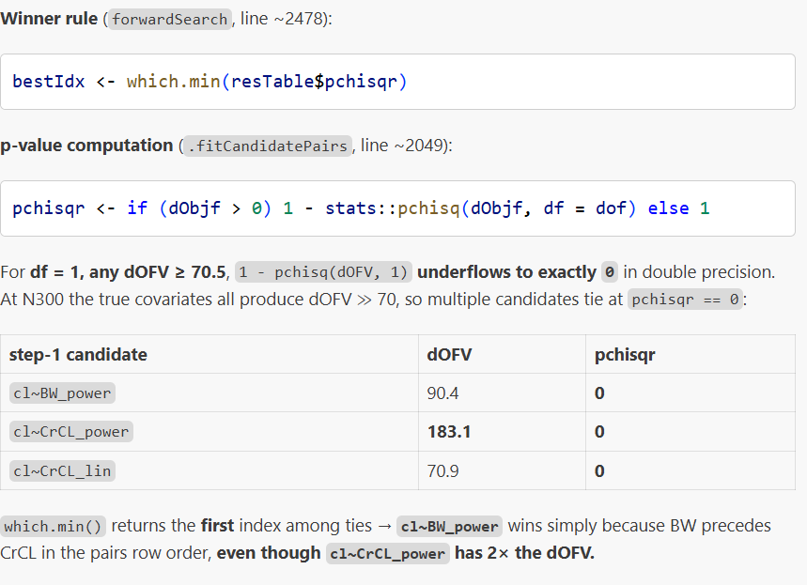
Recommended benchmark config: maxRetries = 0, profileInitOnStall = TRUE, stallTol = 0.
Lincmt -analytial solution – smooth ofv surface – more accurate selection
agg <- "output/scm_bench_rescue_winner_aggregated"
est <- "focei"; opt <- "bobyqa"

source("script/viz/fig_power.R")
p1 <- fig_power(agg_dir = agg, csv_name = "scm_power.csv",
estimator = est, outer_opt = opt,
save = TRUE, out_dir = "output/figures/scm_covsel")

source("script/viz/fig_diag_rates.R")
p2 <- fig_diag_rates(agg_dir = agg, csv_name = "scm_diag_rates.csv",
estimator = est, outer_opt = opt,
save = TRUE, out_dir = "output/figures/scm_covsel")

source("script/viz/fig_error_metrics.R")
p3 <- fig_error_metrics(agg_dir = agg, scenario = 16,
csv_all = "scm_estim_all.csv", csv_cond = "scm_estim_cond.csv",
estimator = est, outer_opt = opt,
save = TRUE, out_dir = "output/figures/scm_covsel")

source("script/viz/fig_covsel_heatmap.R")
p4 <- fig_covsel_heatmap_scm(agg_dir = agg, structure = "both",
estimator = est, outer_opt = opt,
show_title = FALSE, save = TRUE)
cat("all four saved for", est, opt, "\n")

Convergence
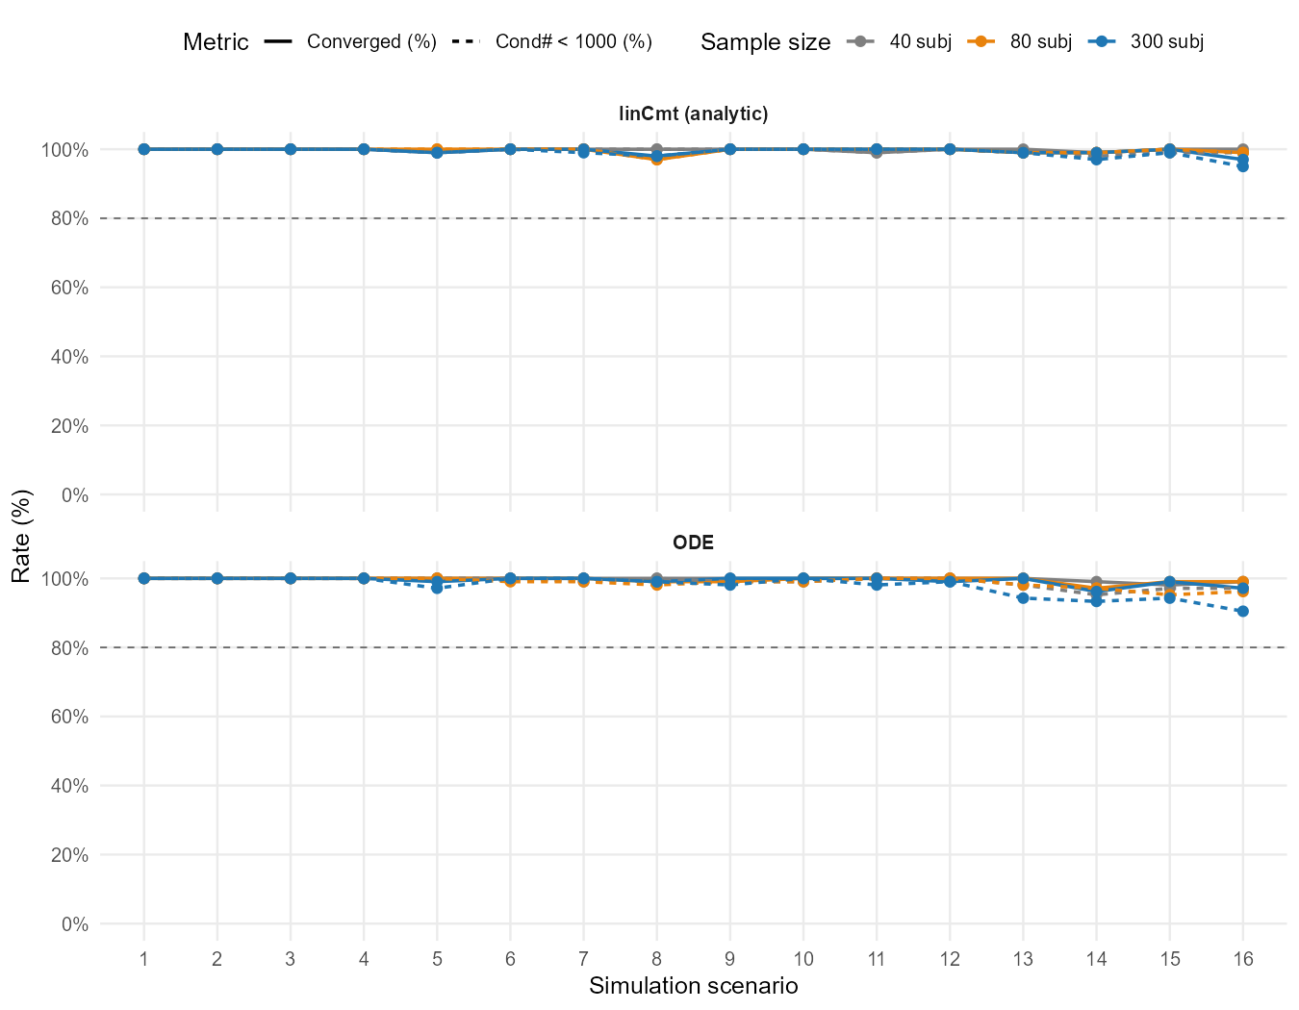

Power (proportion of true covariate selection) – all iterations
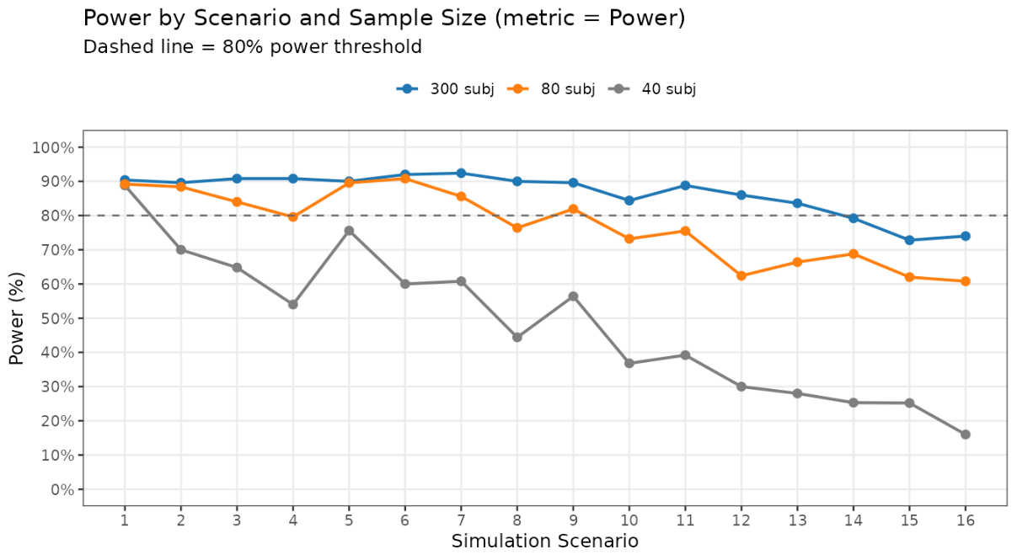
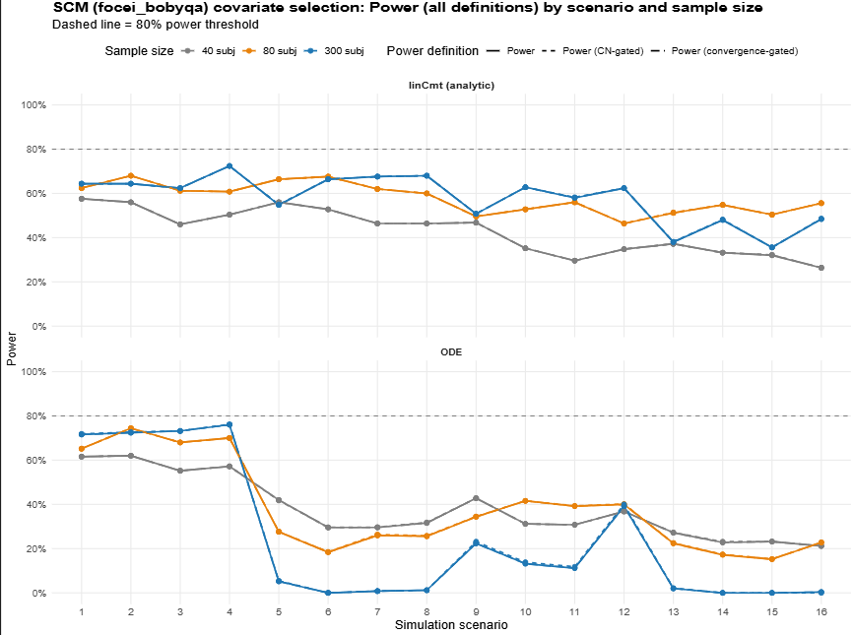
To fixe covariate selection error in ODE setting: Two fixes are key
- Introduce 1-D profileOn for warm start: which is essentially fix all the population parameters and individual random effects from last base run and only estimate the covariate effect<- then warm start.
- Another failure mode: winner selection becomes random when p-value ties.

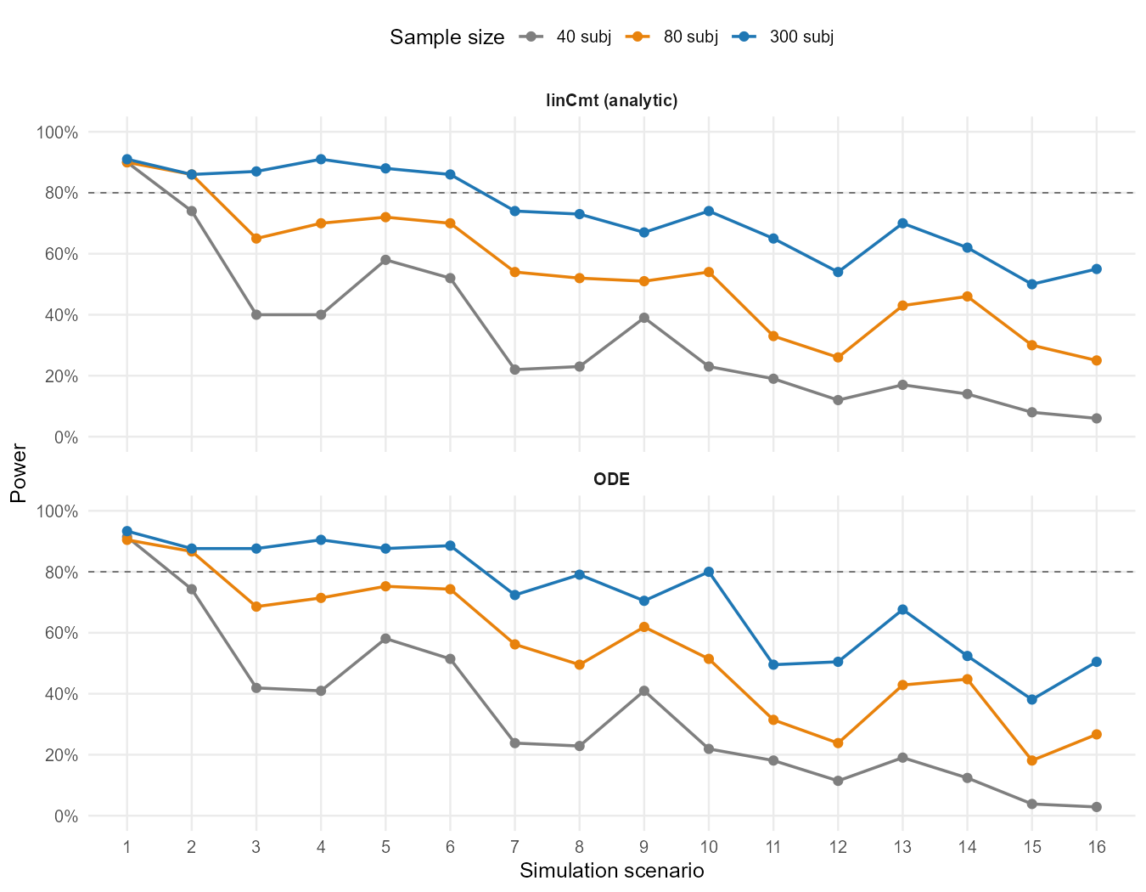
This is because we fix the winner section tie bug. Before that, when pvalue tie, always select power [which is the ordered above lin]; after that, when tie, occasionally select lin.
output/scm_bench_rescue_winner_aggregated -with profileInitON + corrected winner selection + exact match

Heatmap of covariate selection Pattern: FP, FN
source("script/viz/fig_covsel_heatmap.R")
p <- fig_covsel_heatmap_scm(sample_N = 300, structure = "linCmt",
estimator = "focei", outer_opt = "bobyqa",
labels = FALSE)
ggplot2::ggsave("output/figures/scm_covsel/_test_n300.png", p, width = 11, height = 9, dpi = 150)
print(p)
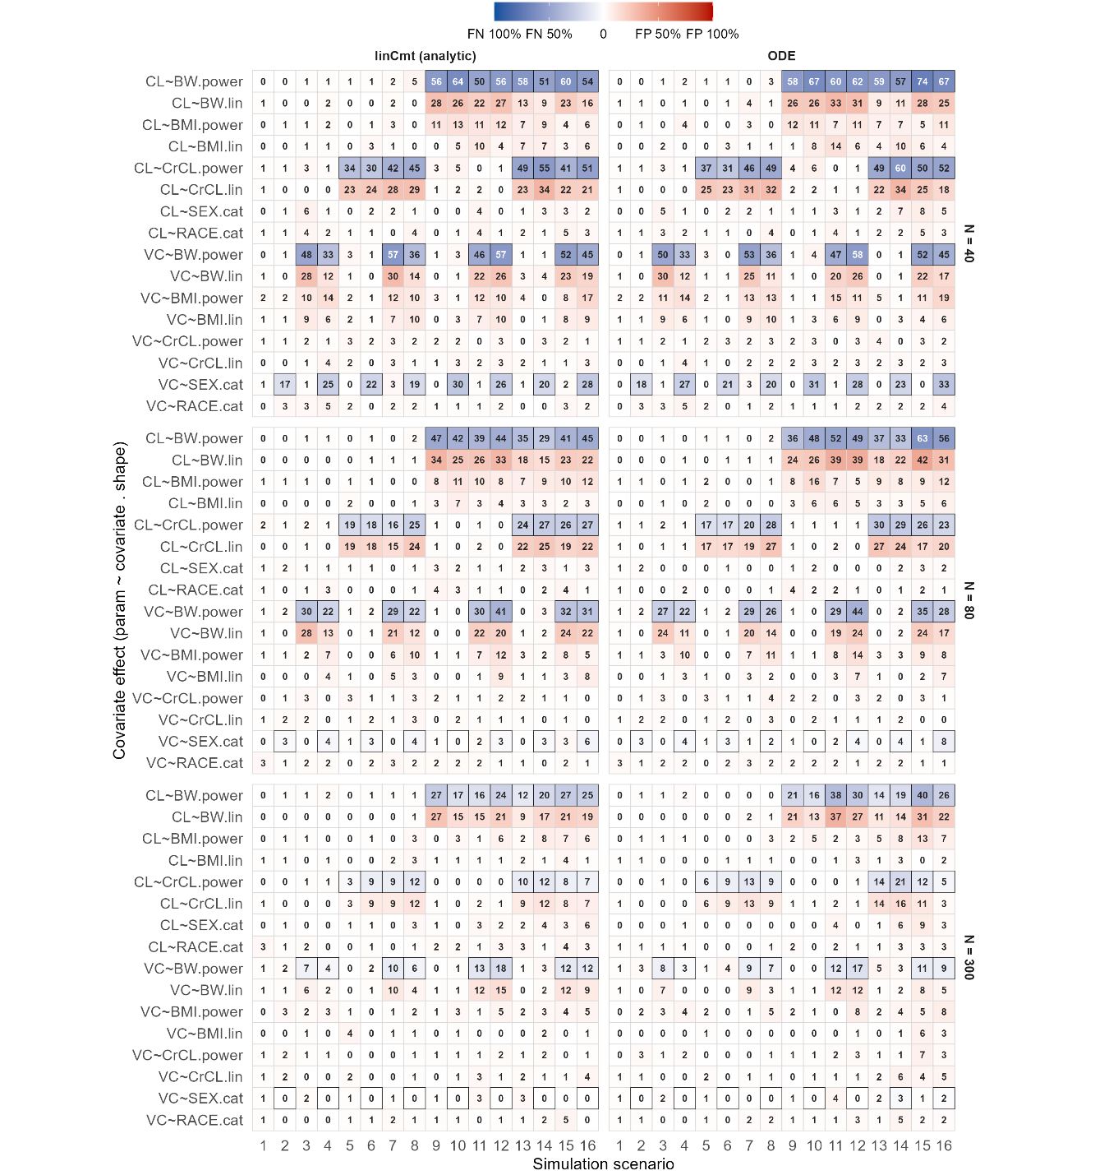

Relative mean root squared error (RMRSE) & median absolute square error
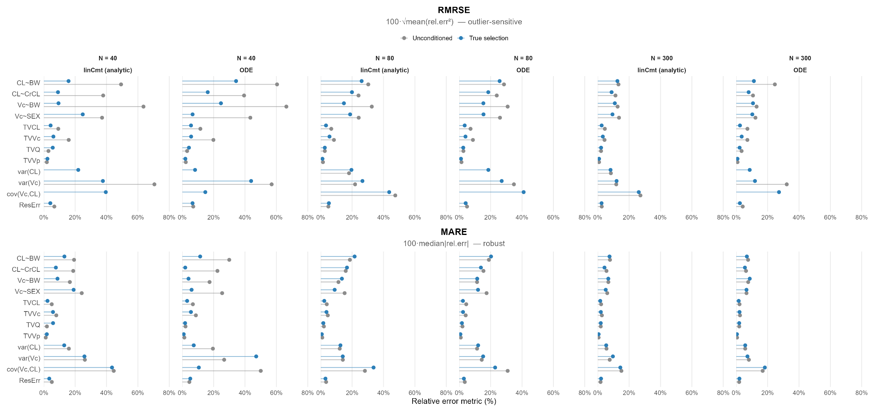
Omega variance and covariance

scm _irlsfocei_bobyqa [Parked for now]
agg <- "output/scm_bench_rescue_winner_aggregated"
est <- "irlsfocei"; opt <- "bobyqa"
source("script/viz/fig_power.R")
p1 <- fig_power(agg_dir = agg, csv_name = "scm_power.csv",
estimator = est, outer_opt = opt,
save = TRUE, out_dir = "output/figures/scm_covsel")
source("script/viz/fig_diag_rates.R")
p2 <- fig_diag_rates(agg_dir = agg, csv_name = "scm_diag_rates.csv",
estimator = est, outer_opt = opt,
save = TRUE, out_dir = "output/figures/scm_covsel")
source("script/viz/fig_error_metrics.R")
p3 <- fig_error_metrics(agg_dir = agg, scenario = 16,
csv_all = "scm_estim_all.csv", csv_cond = "scm_estim_cond.csv",
estimator = est, outer_opt = opt,
save = TRUE, out_dir = "output/figures/scm_covsel")
source("script/viz/fig_covsel_heatmap.R")
p4 <- fig_covsel_heatmap_scm(agg_dir = agg, structure = "both",
estimator = est, outer_opt = opt,
show_title = FALSE, save = TRUE)
cat("all four saved for", est, opt, "\n")

Convergence status
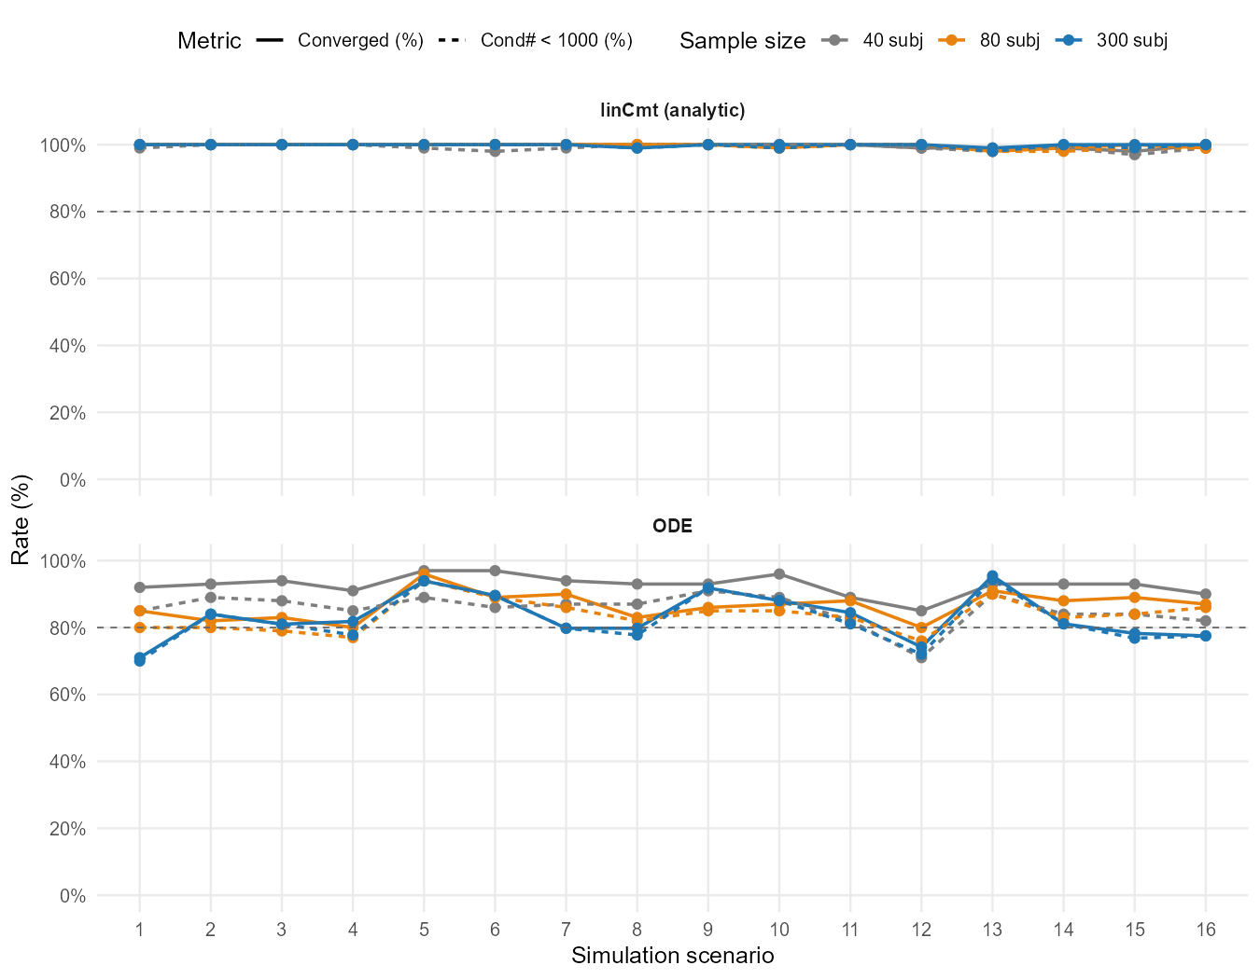

Power (proportion of true covariate selection)
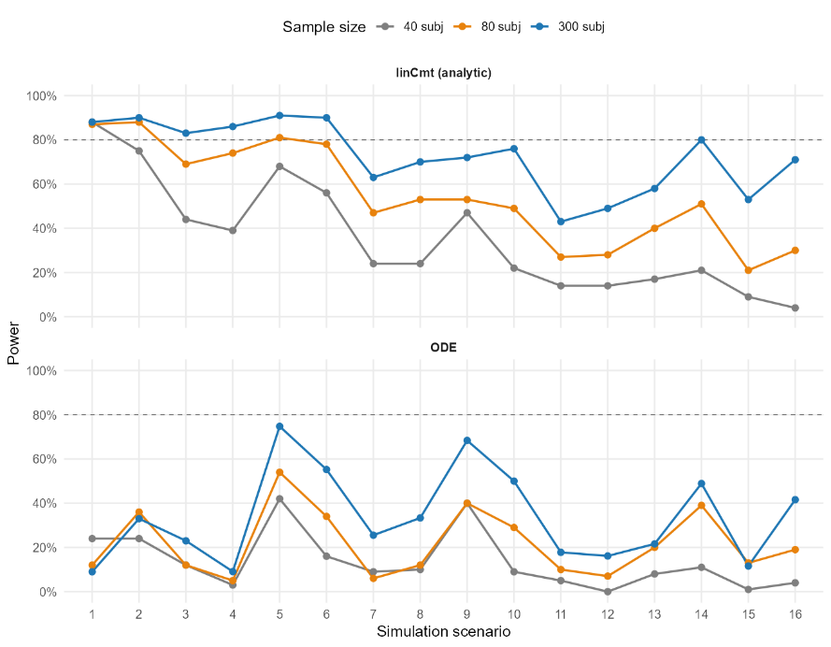

Heatmap of covariate selection Pattern: FP, FN
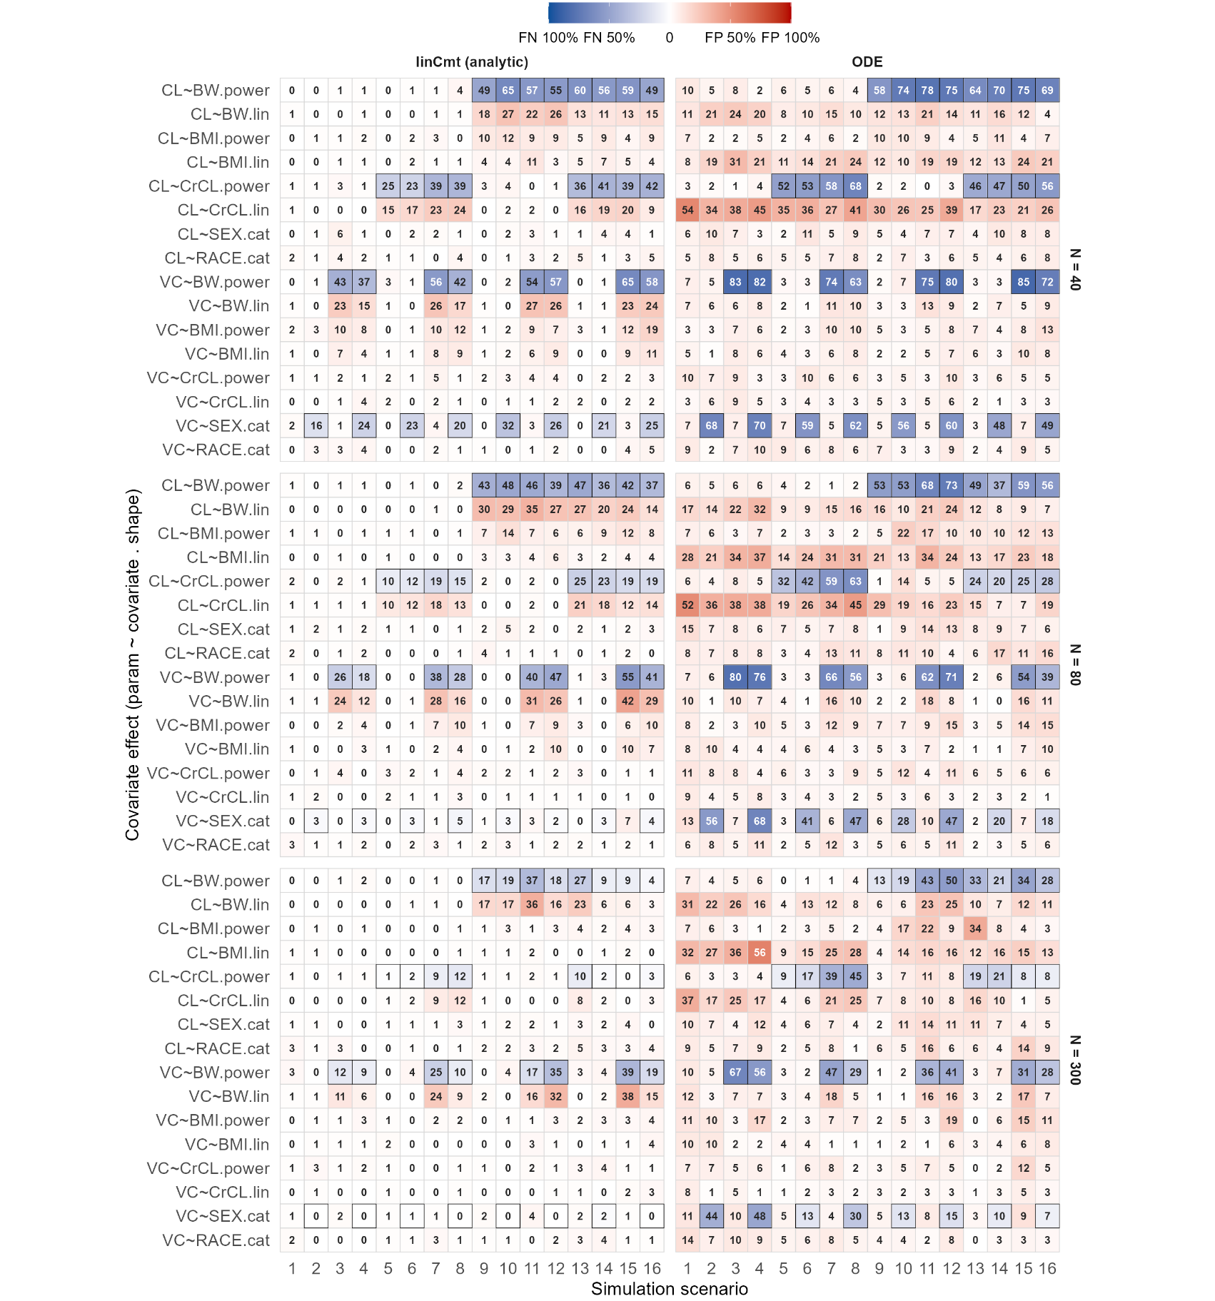

Relative mean root squared error (RMRSE) & median absolute square error
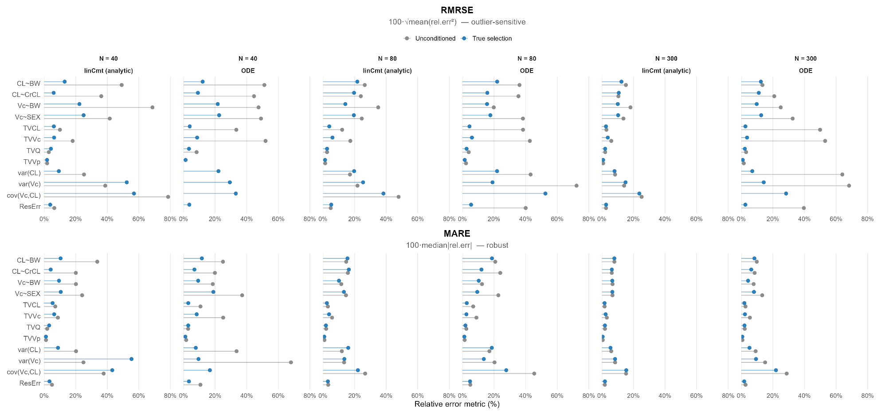

2. Vae.

Covariate selection-one run_nlmixr2est7.0.1 [Outdated]
Need to rerun, this version doesn’t support (1) estimation of the off-diagonal of omega metrics and (2) user-specified cov-var relationship centering&shape.

Convergence status
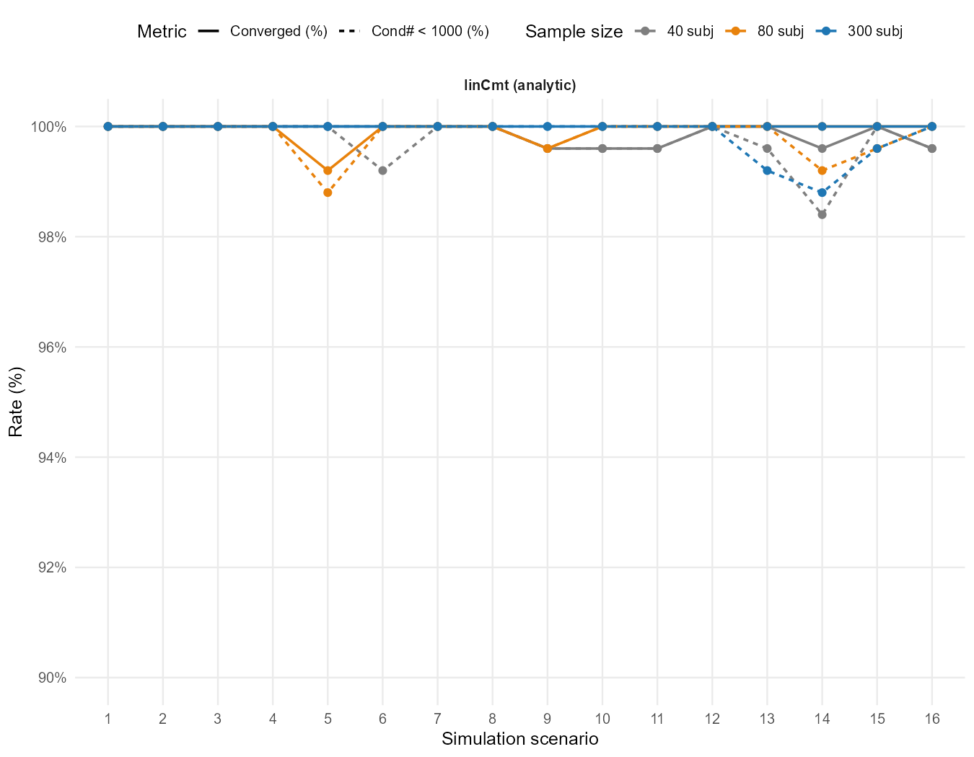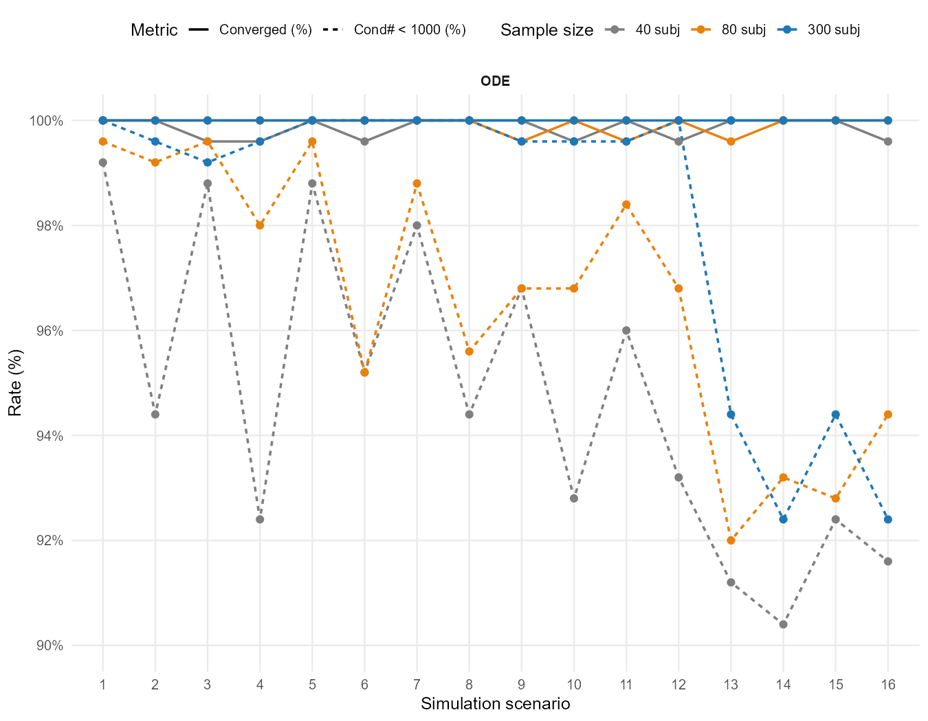

source("script/viz/fig_diag_rates.R")
p <- fig_diag_rates(
agg_dir = "output/vae_covsel_full0723_est710_aggregated",
metric = "CNBelowCutoff",
structure = NULL, # both linCmt + ode, faceted
ylim = c(90, 100),
save = TRUE
)
print(p)

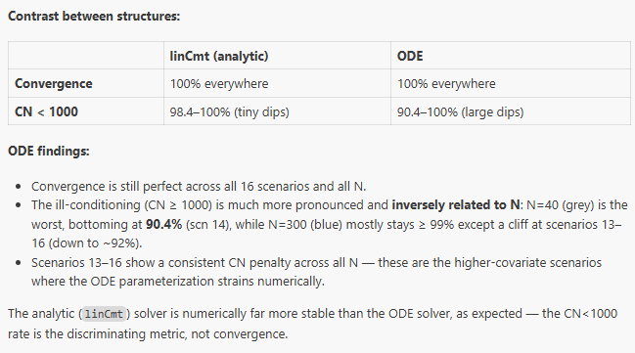

Power (proportion of true covariate selection) - reruned
Power metrics * Sample size * structure
7.0.0 nlmixr2est [new run have the similar power curve as previous run]
source("script/viz/fig_power.R")
fig_power(
agg_dir = " output/vae_covsel_aggregated0722", # no stray space
csv_name = "vae_power.csv", # SCM aggregator's filename
title_prefix = "VAE covariate selection",
metric = c("Power", "PowerCN", "PowerMinSuc"),
sample_N = NULL,
structure = NULL,
save = FALSE )
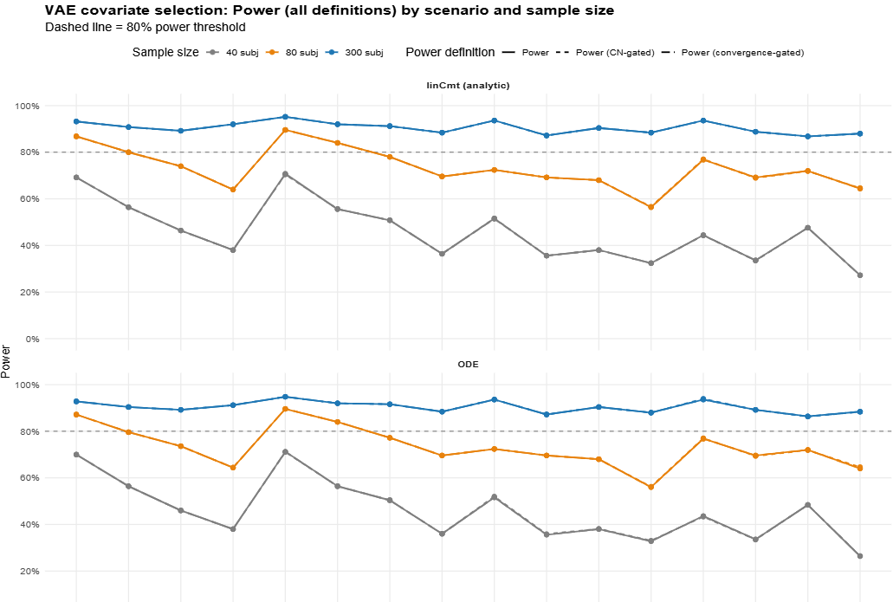

nlmixr2est7.0.1
source("script/viz/fig_power.R")
fig_power(
agg_dir = "output/vae_covsel_full0723_est710_aggregated", # note: no leading space
metric = c("Power", "PowerCN", "PowerMinSuc"),
sample_N = NULL, # all N
structure = NULL, # both structures
save = TRUE # writes PNG + PDF)
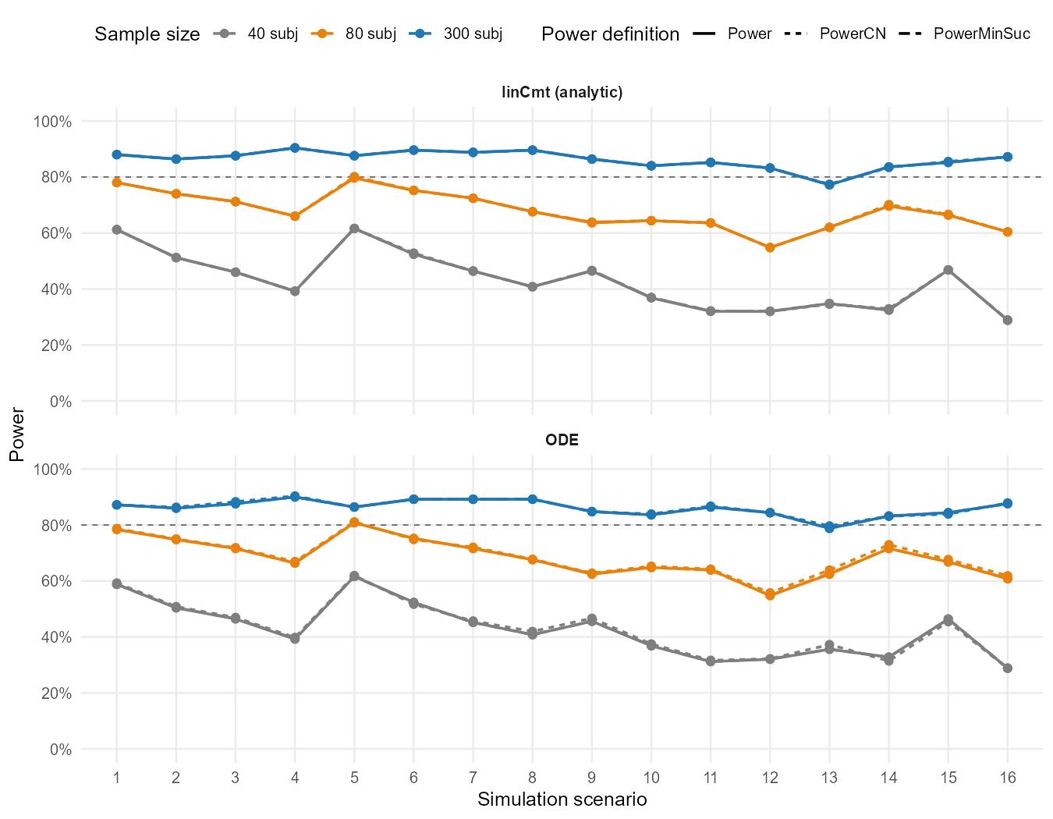

Insights:
- VAE converged successfully & CN<1000 (100%- power metrics overlap)
- Commendable performance for N=300 (power>85% for sc16) N=80 (power>64% for sc16)
- Lincmt and ODE model structure don’t impact ODE-covariate selection performance

Update vae on 7/23. 7.0.1 Cran

Heatmap of covariate selection Pattern: FP, FN
7.0.0 nlmixr2est
source("script/viz/fig_covsel_heatmap.R")
fig_covsel_heatmap(
agg_dir = "output/vae_covsel_aggregated0722",
sample_N = NULL, # all N
structure = "linCmt", # one structure per figure; use "ode" to swap
save = false

source("script/viz/fig_covsel_heatmap.R")
fig_covsel_heatmap(agg_dir = "output/vae_covsel_aggregated0722",
structure = "ode", save = TRUE)
source("script/viz/fig_covsel_heatmap.R")
p <- fig_covsel_heatmap(agg_dir = "output/vae_covsel_aggregated", structure = "both")
print(p)
invisible(fig_covsel_heatmap(agg_dir = "output/vae_covsel_aggregated",
structure = "both", save = TRUE))

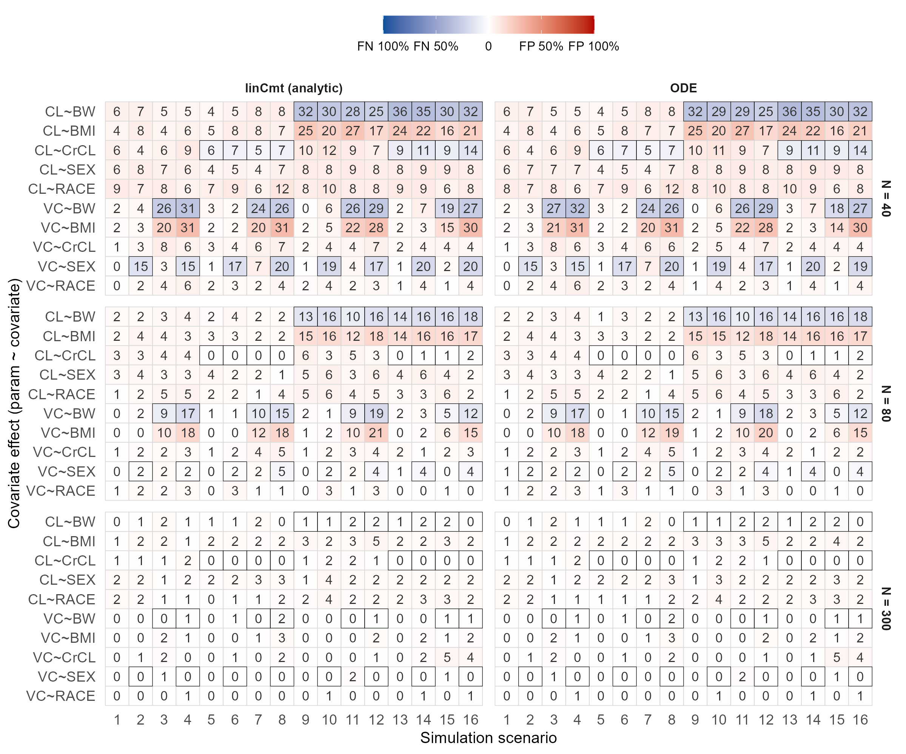

Relative mean root squared error (RMRSE) & median absolute square error
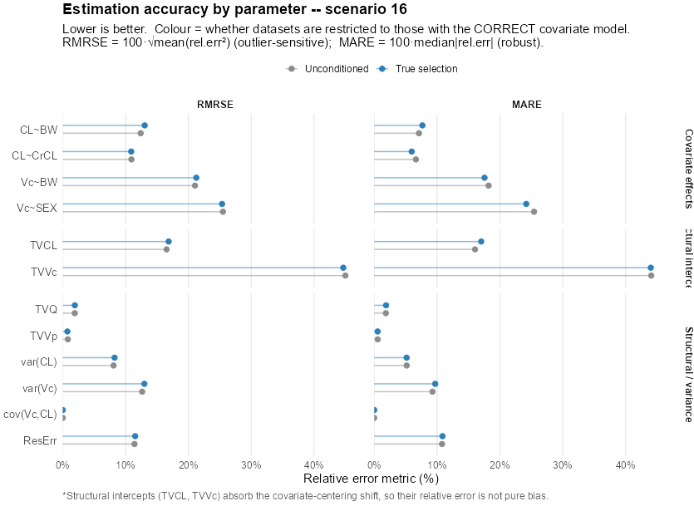
This is before the transformation. The data was simulated with weight and CL centered at 70 and 95.
But runscm by default centered at median, and vae by default centered at mean.
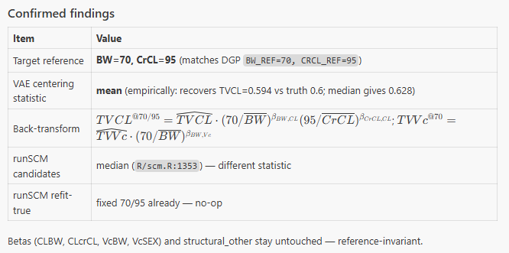
This is after transformation.
How RunSCM works
For vae
.covType[j] <- "continuous"; .covPop[j] <- mean(v); .covMat[, j] <- log(v / .covPop[j])
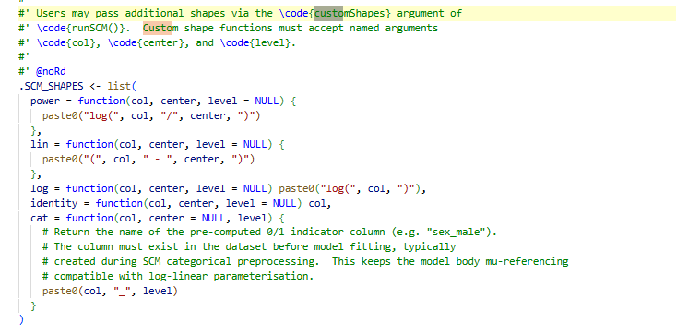
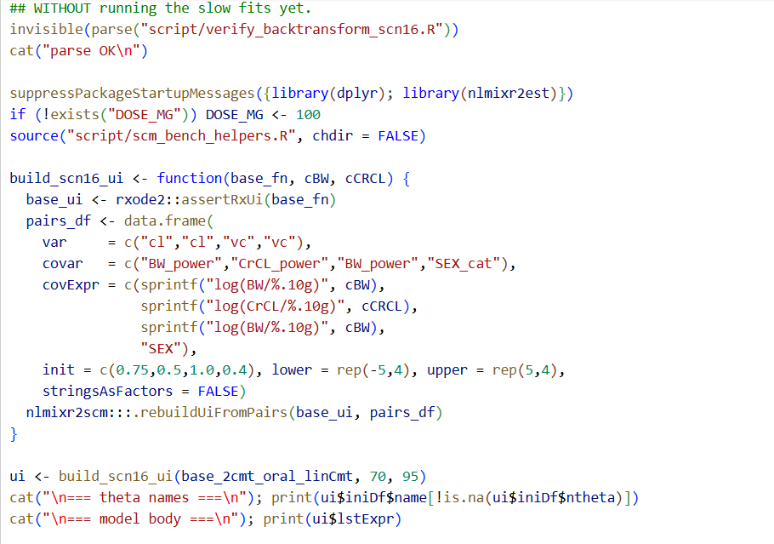
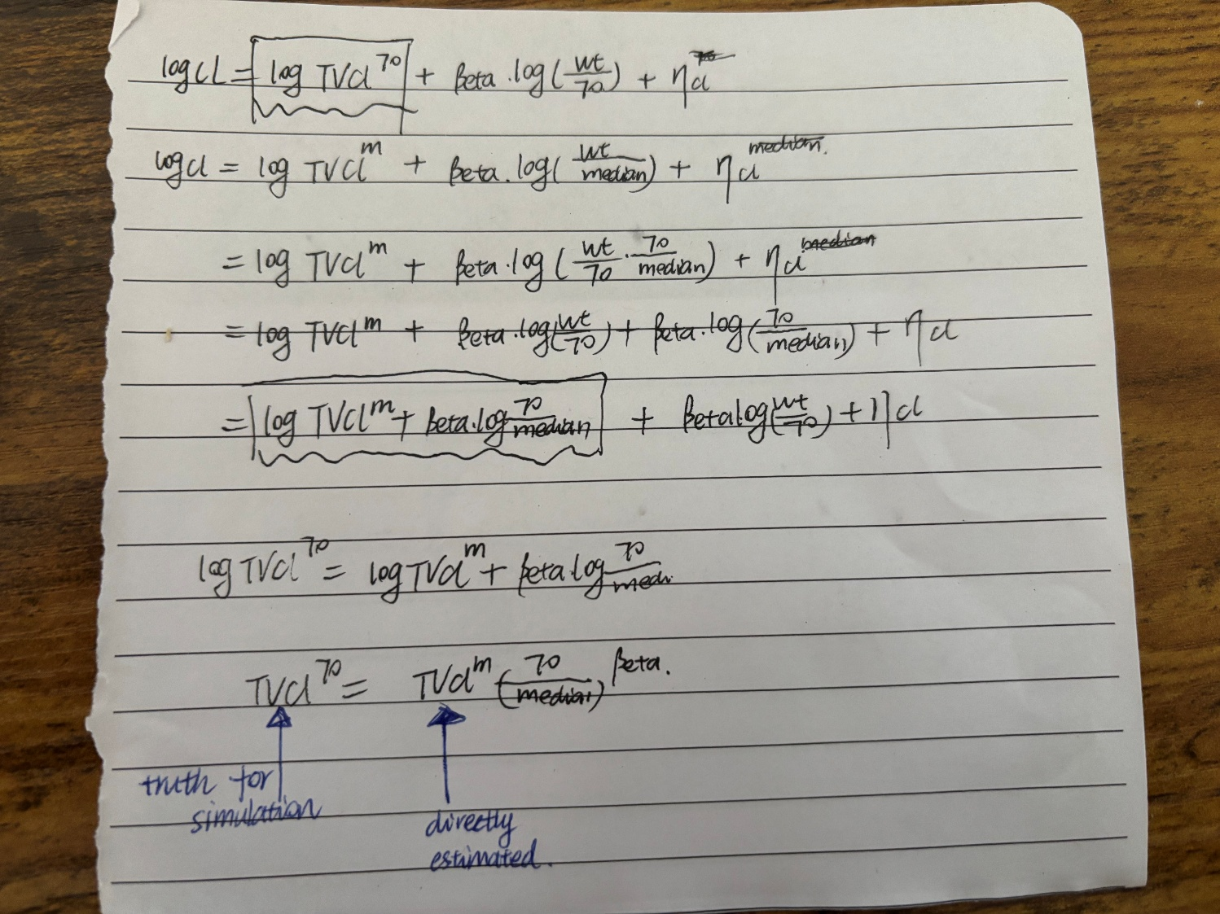

Contrasting runscm & vae center at 70/95 vs. backward transformation
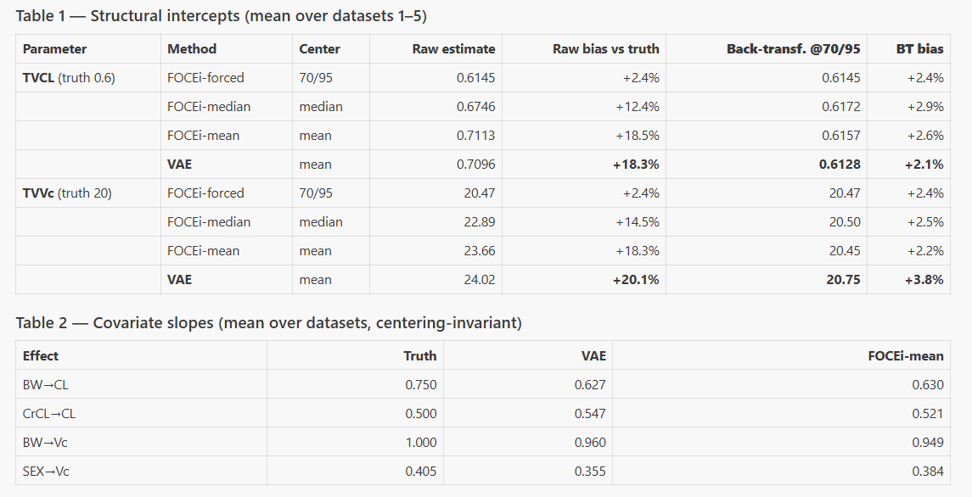
"The VAE is not biased — it reports typical values at the covariate mean, not the clinical reference. Re-anchoring to WT=70 / CrCL=95 via the standard allometric back-transform brings VAE, FOCEi, and the true model into agreement (all within ~3% of truth)."

Off-diagonal of the omega metrics is not available in vae 7.0.1
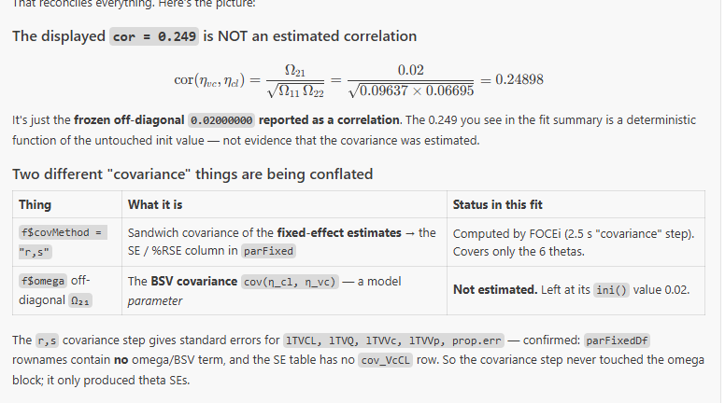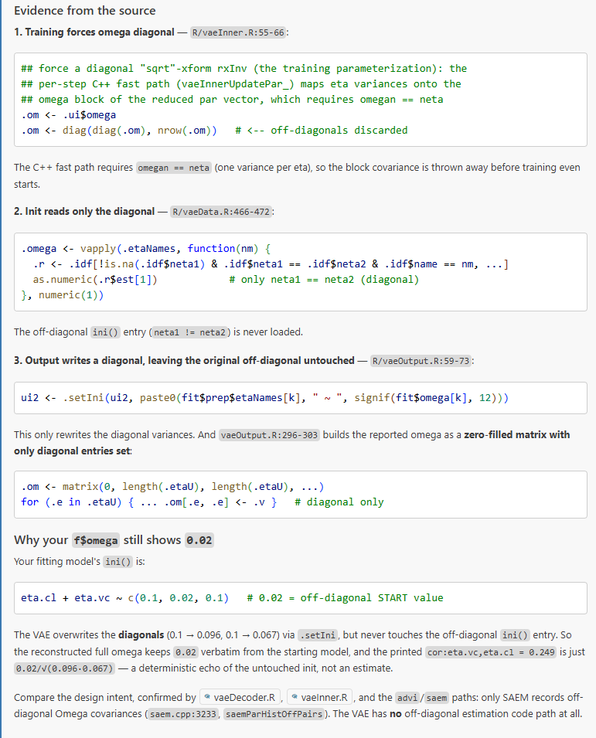
source("script/viz/fig_error_metrics.R")
p <- fig_error_metrics(
agg_dir = "output/vae_covsel_full0723_est710_aggregated",
scenario = 16,
structure = "linCmt",
metrics = c("RMRSE", "MARE"),
drop_fixed = TRUE,
save = TRUE
)
print(p)
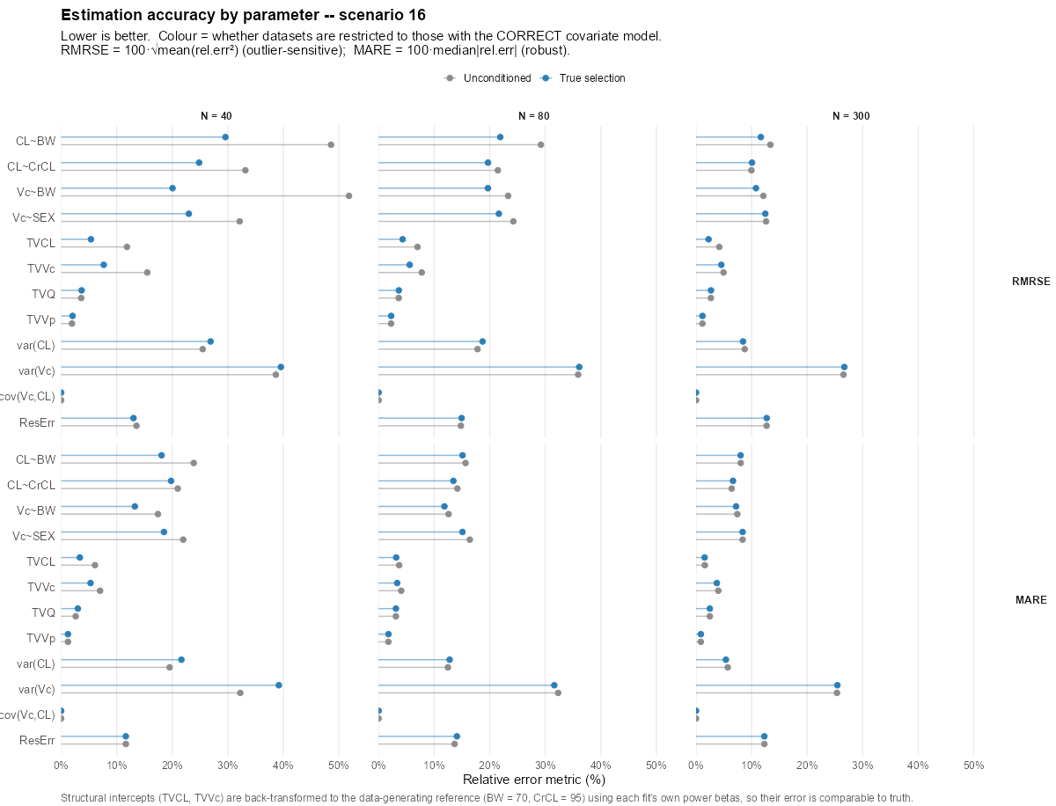

Covariate selection-one run_nlmixr2est7.0.2 07/29/2026
this version support (1) estimation of the off-diagonal of omega metrics and (2) user-specified cov-var relationship centering&shape.

Convergence status

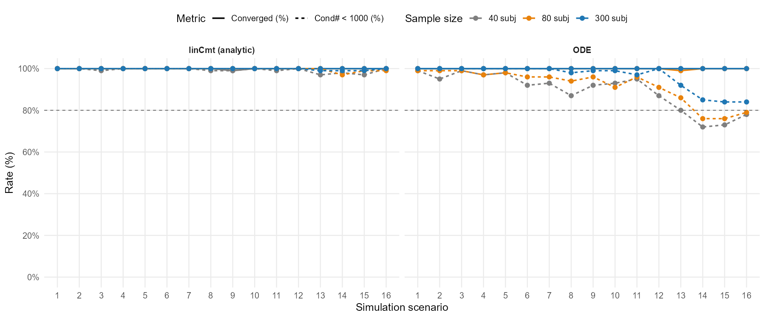

Power (proportion of true covariate selection) - reruned
Power metrics * Sample size * structure
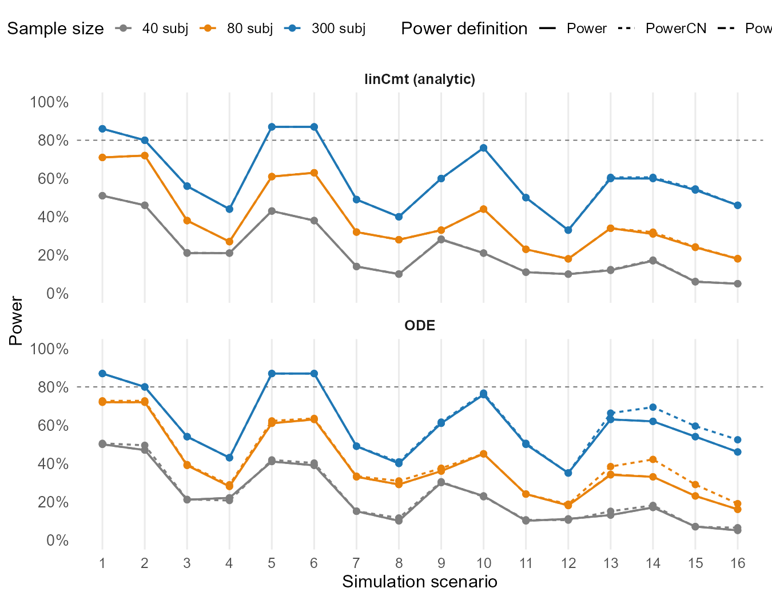

Heatmap of covariate selection Pattern: FP, FN
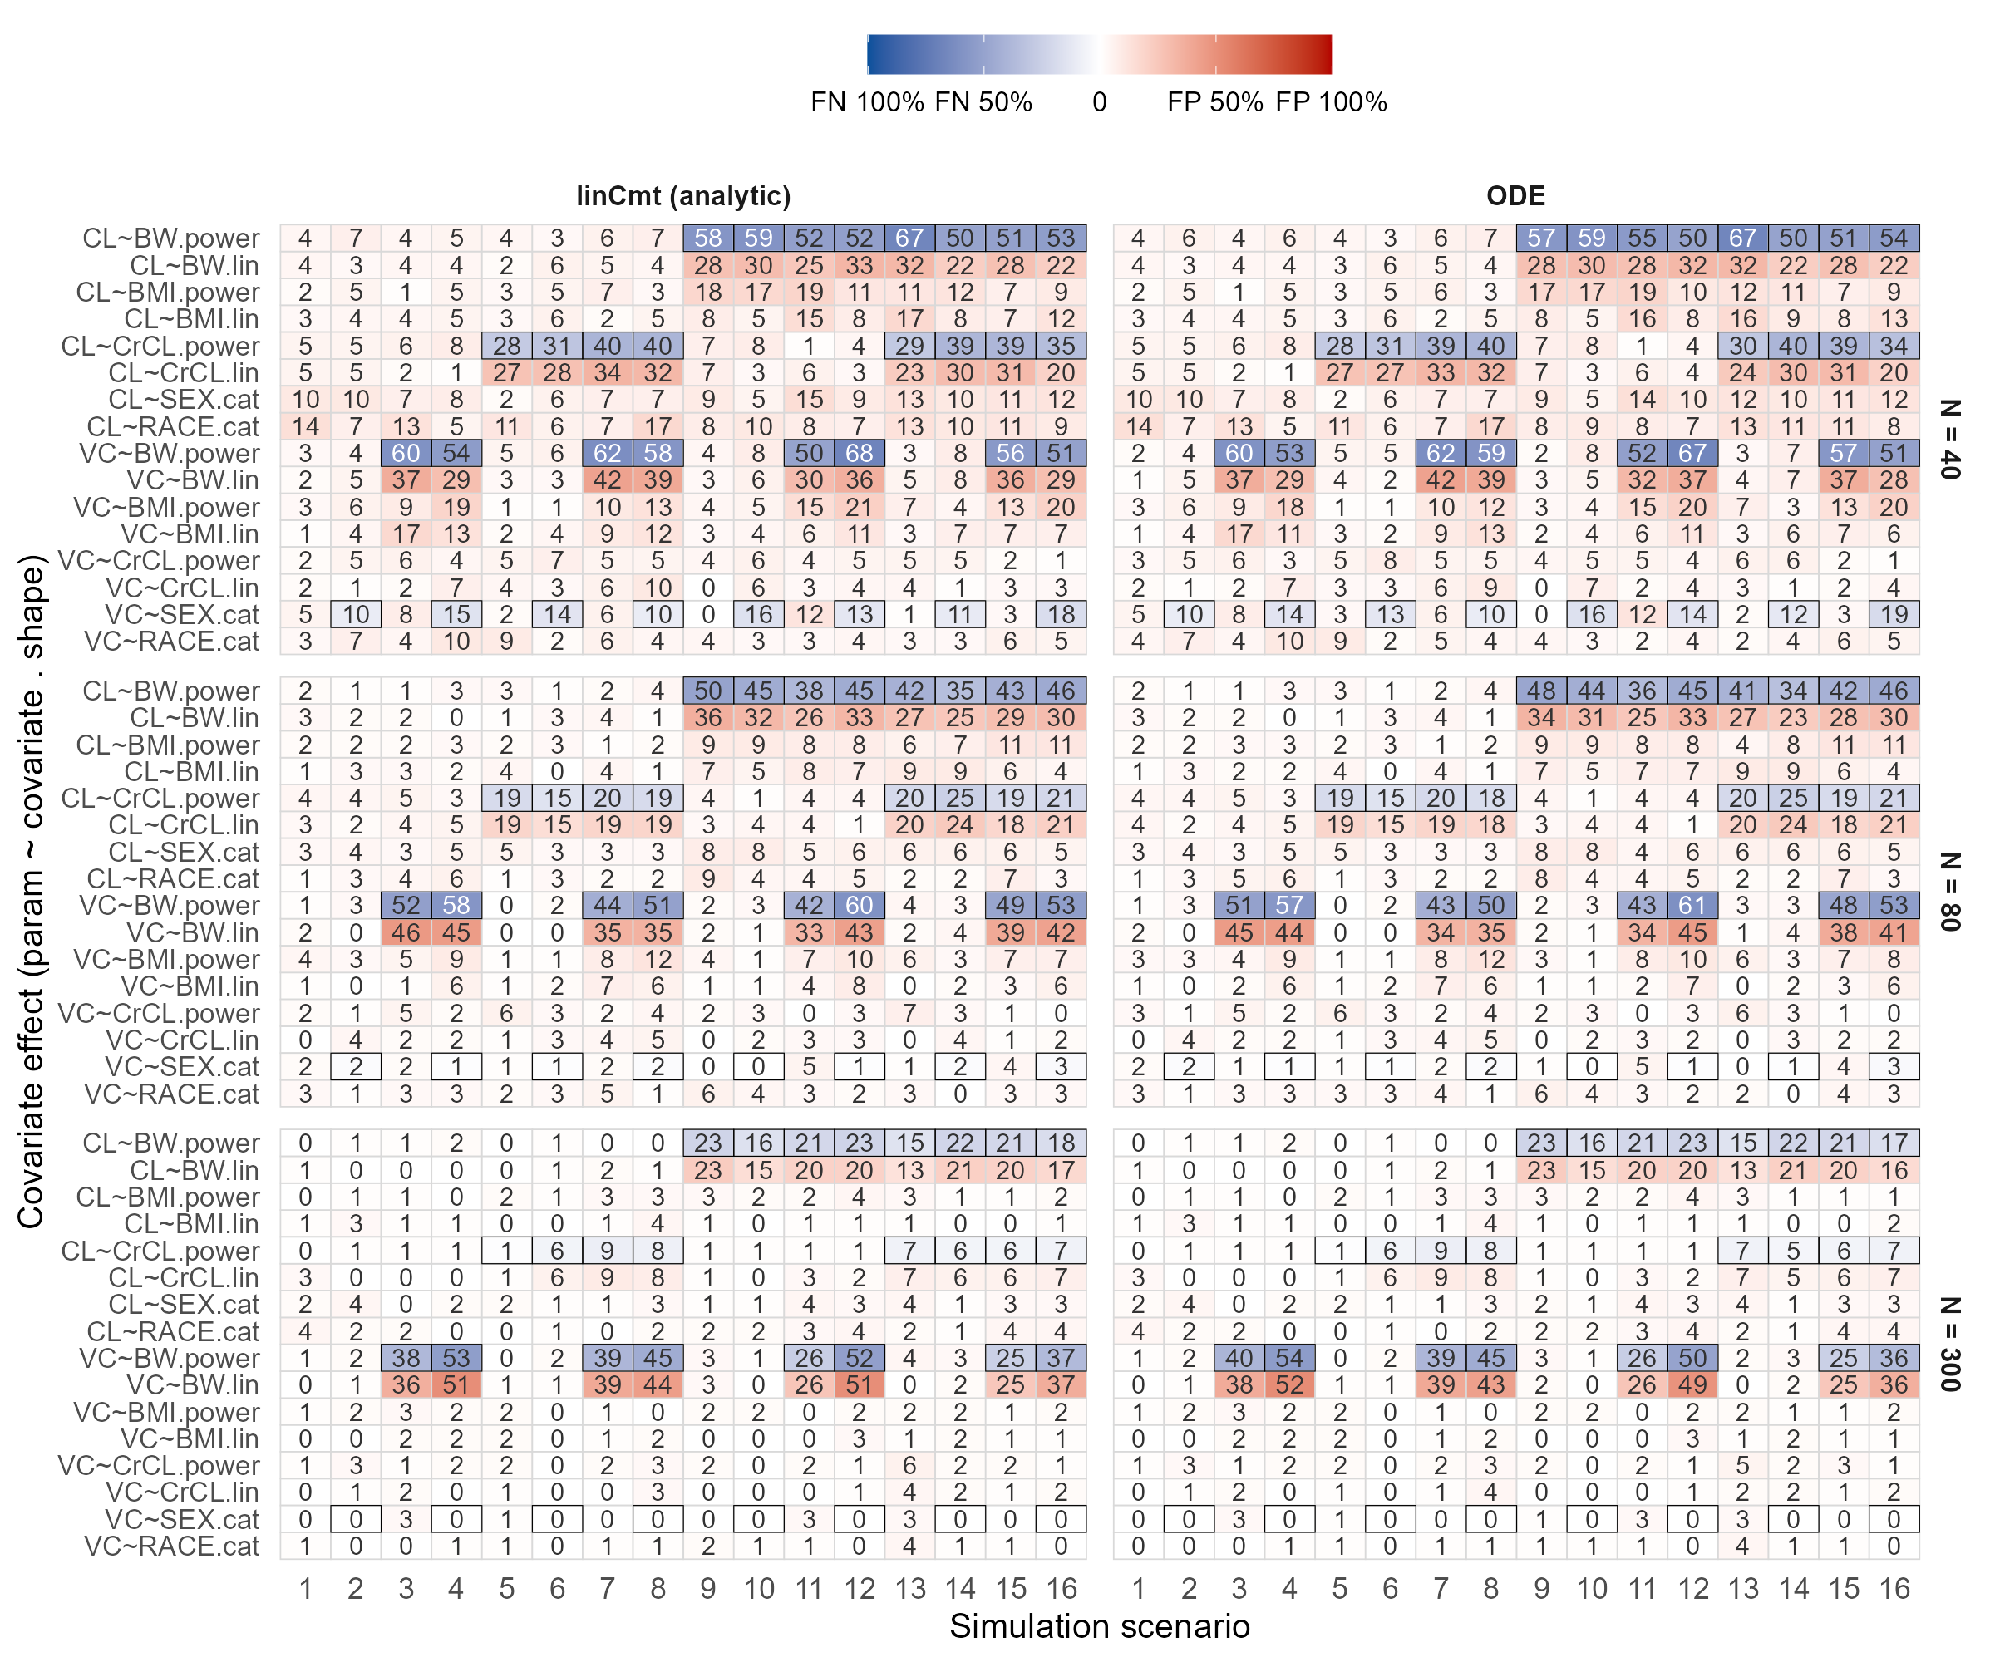

Relative mean root squared error (RMRSE) & median absolute square error
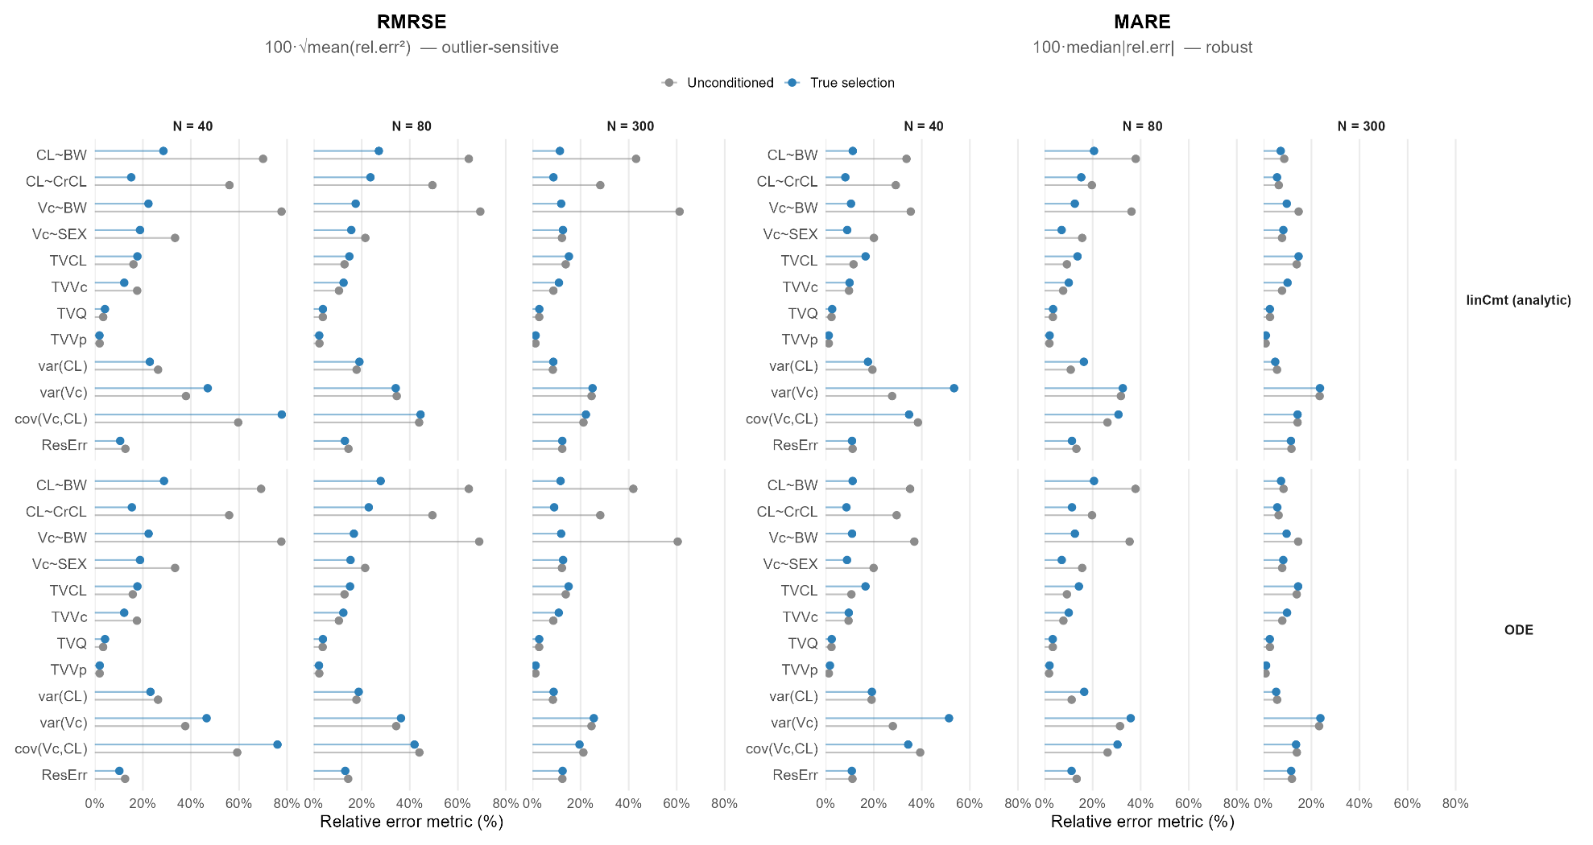

Refit doesn’t work as good as covariate selection, which is expected as two different estimation mode.
Test VAE's POPULATION-ONLY / fixed-structure mode:
nlmixr2(true_mod, ds, est = "vae", control = vaeControl(covariateSelection = FALSE))
initial estimates doesn’t move.

07/23 7.0.0 nlmixr2est : initial estimates moved but use regressors for calculation. Which didn’t give the covariate effect estimates as accurate as vae-ELBO did. Parked the issue 07/23
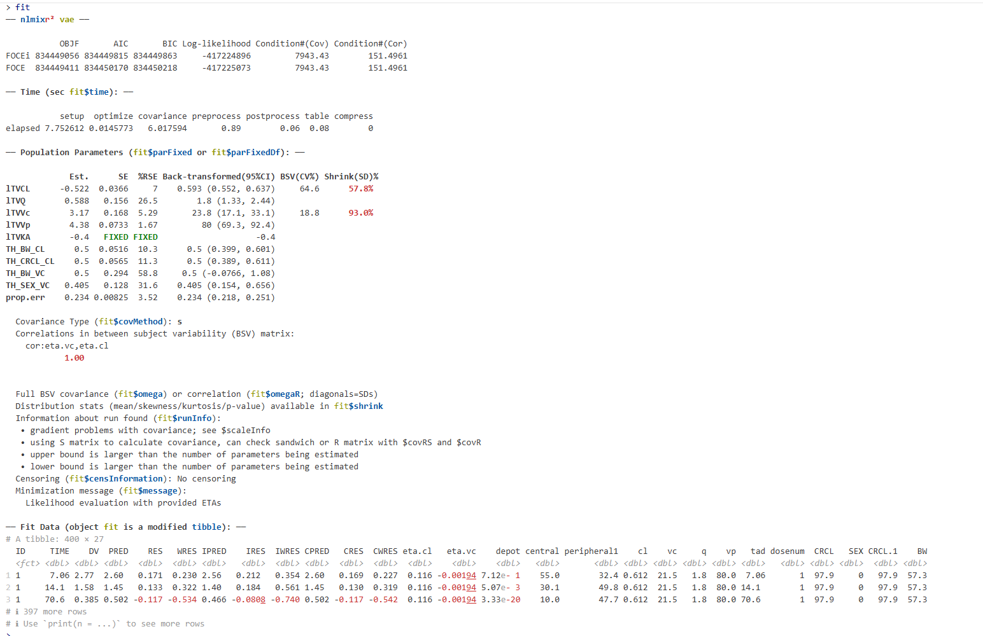

07/21 on updated vae+lincmt
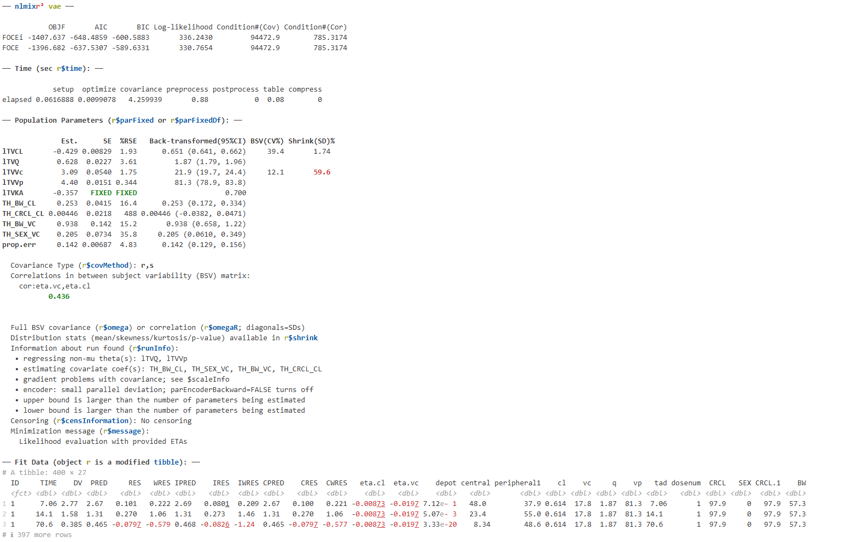

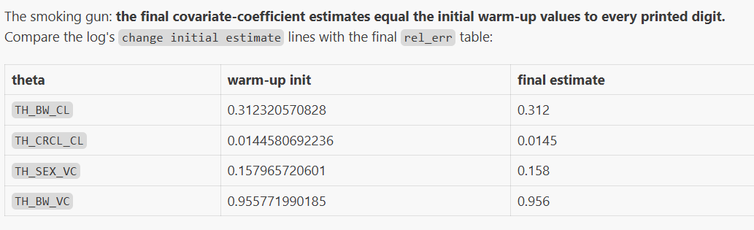
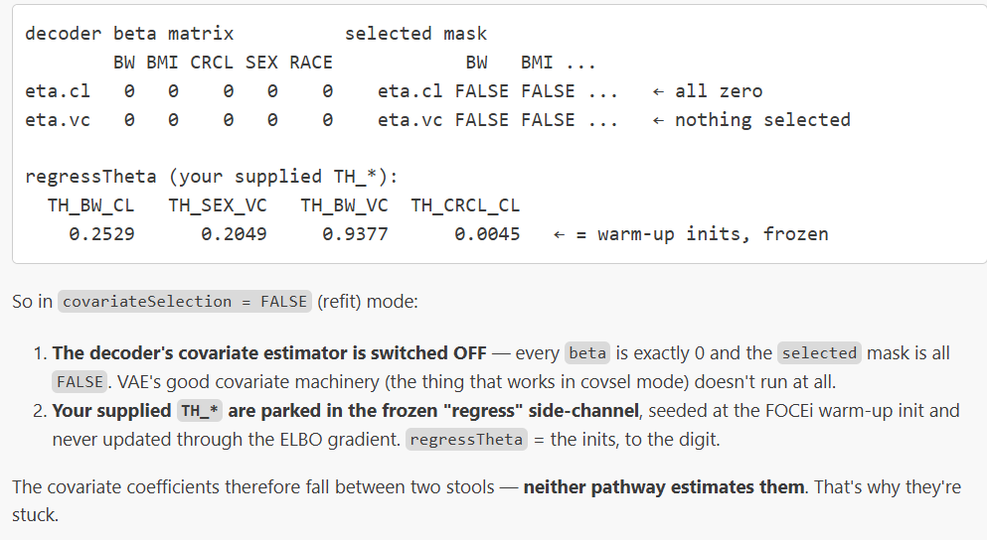
covariateSelection = FALSE; It looks like it fits the base/population model and treats the covariate coefficients as fixed constants.

3.Gradient/derivative-based estimator
07/23
For irksfoceif, current model and datasets are too complicated for analytic gradient to solve. It degrades to finite difference.
But irls might still speed up. Run ifocei-lbfgsb3c. ifocei-bobyqa
Scm_bench lincmt is before the fix of winner selection tie currently rerun and saved in scm_bench_rescue_winner.
Scm_bench ode is after Brent+winnder selection

find output/scm_bench_rescue_winner -name 'res_ds*.rds' ! -name '*.fit.rds' \
| sed -E 's#output/scm_bench_rescue_winner/(N[0-9]+)/(scn[0-9]+_[^/]+)/([^/]+)/.*#\1 \2 \3#' \
| sort | uniq -c | sort -k2,2

Run these algorithms for 20 datasets and all scenarios
vae | lincmt/ode | -
focei | lincmt/ode | Bobyba/lbfgsb3c
ifocei | Lincmt/ode | Bobyqa/lbfgsb3c
foceif-> fallback on fd | ode | lbfgsb3c
ifoceif-> fallback on fd | ode | lbfgsb3c

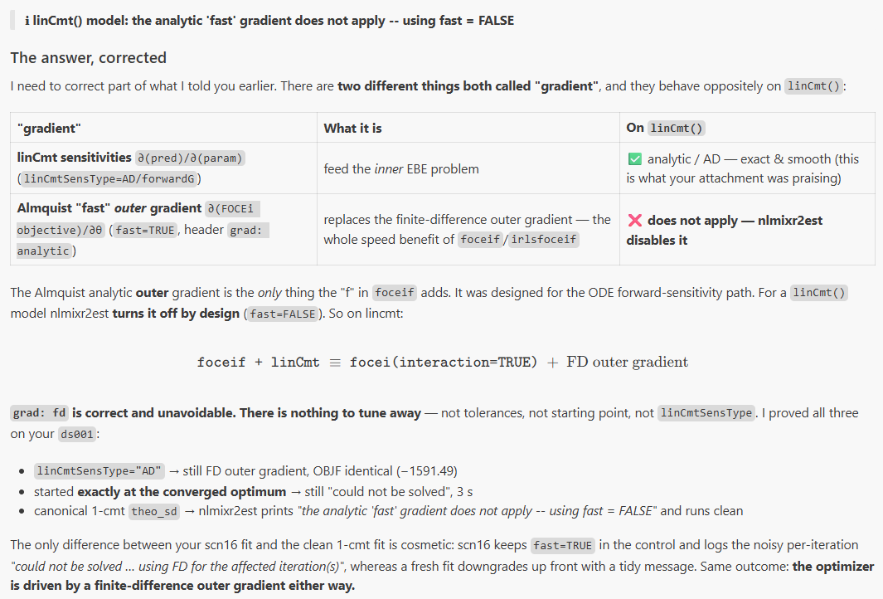

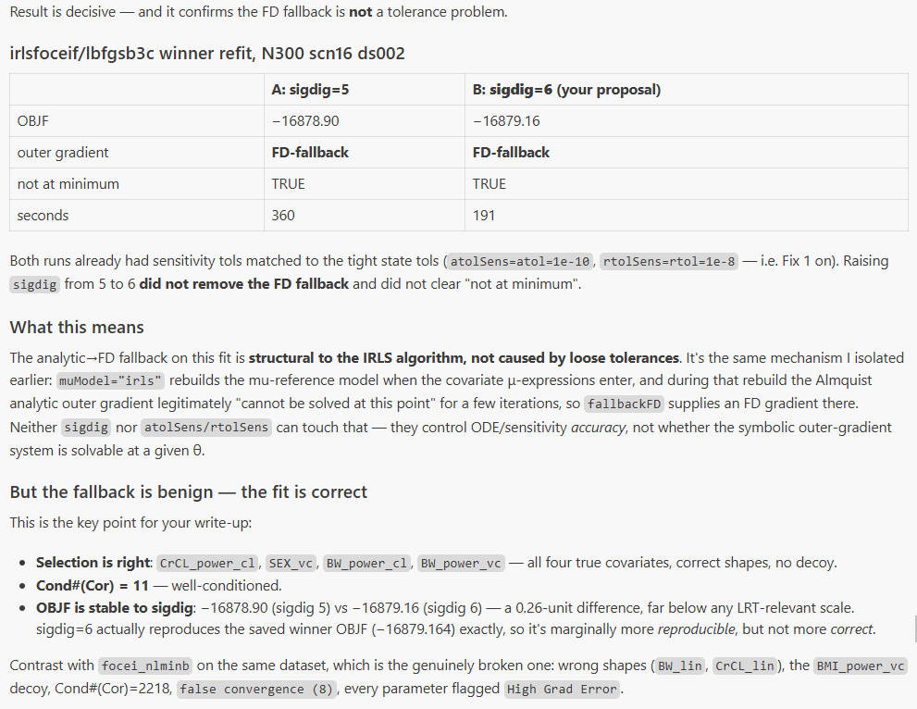

No structural disqualifier trips — so analytic gradient is not permanently disabled. Let me confirm the setup actually succeeds, which would mean the fallback is the intermittent per-iteration solve failing at specific θ points
Now it's pinned down precisely: on the real in-fit env every am prerequisite is TRUE, setup succeeds, and the core throws no error — yet the gradient is still rejected. That means .foceiAnalyticGradCore returns NULL (computes the augmented-sensitivity gradient but rejects it as non-finite/unsolvable), which trips FD. So fallbackFD isn't the thing to fix — it's a symptom; the core is refusing its own result.
3.Gradient/derivative-based estimator

4.Runtime Benchmark
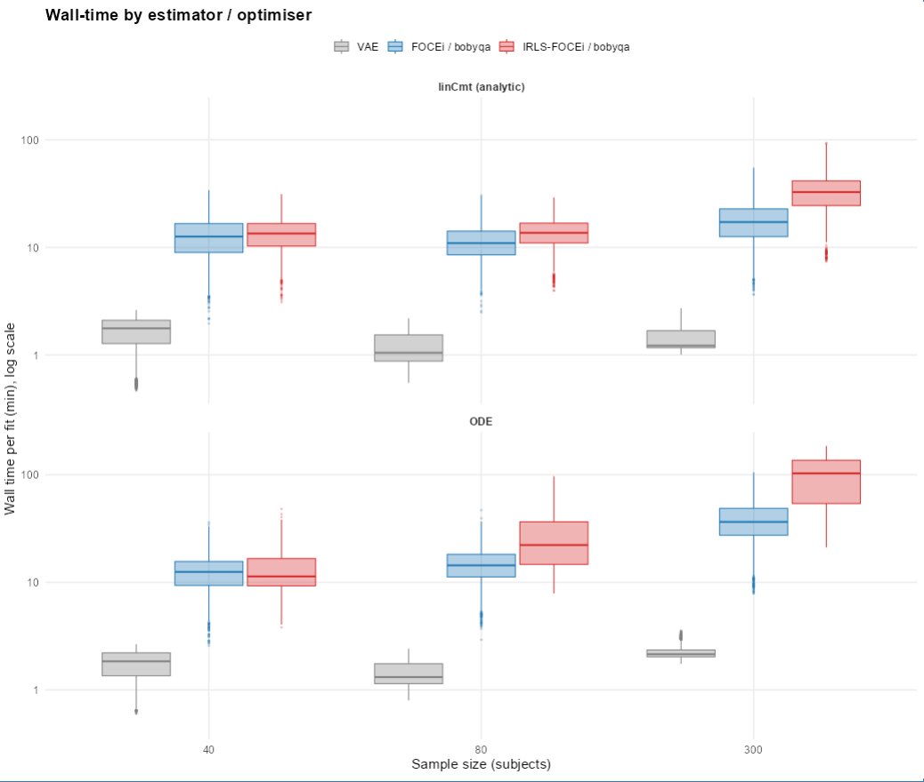

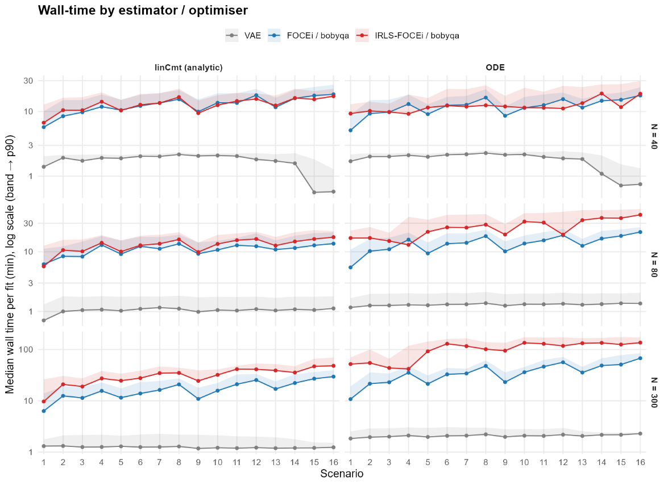
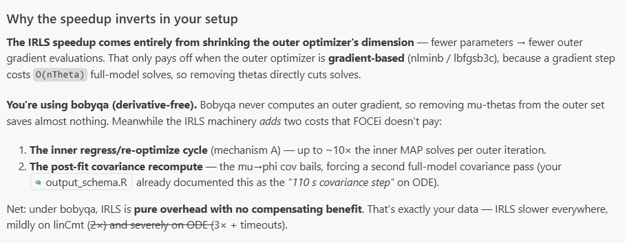
IRLS-FOCEi is only faster when paired with a "slope-following" optimizer; you paired it with bobyqa (which doesn't follow slopes), so you got all of IRLS's extra overhead and none of its benefit — and that overhead multiplies against the already-slow ODE model, causing the timeouts.

5.PsN counterpart
Here are the nlmixr2 shape builders:
power = log(col/center) # inside exp(lTVCL + …) ⇒ TVCL*(cov/center)^θ → PsN POWER
lin = (col - center) # inside exp(lTVCL + …) ⇒ TVCL*exp(θ(cov-center)) → PsN EXPONENTIAL
cat = col_level (0/1) # inside exp(…) ⇒ TVP*exp(θ·I) → exponential categorical
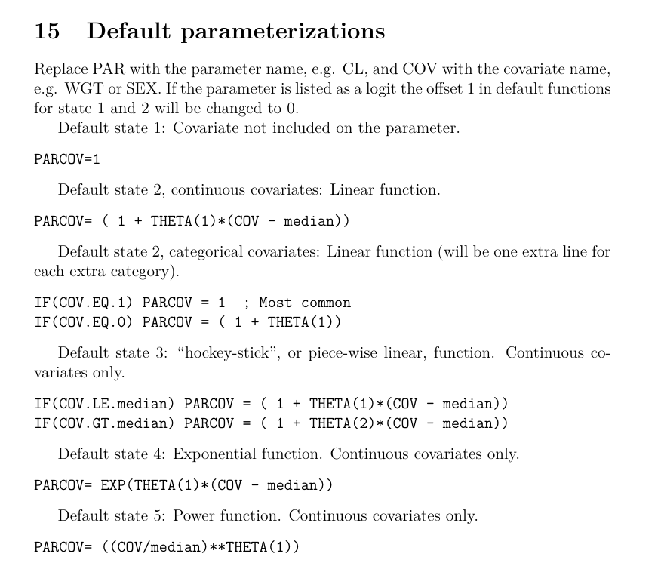
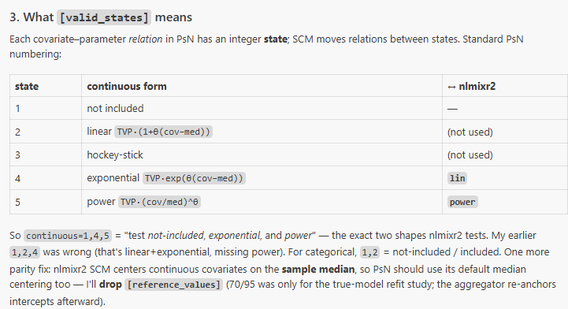
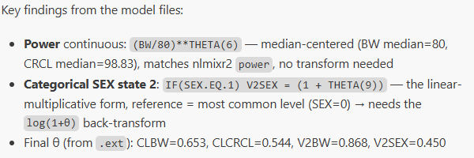
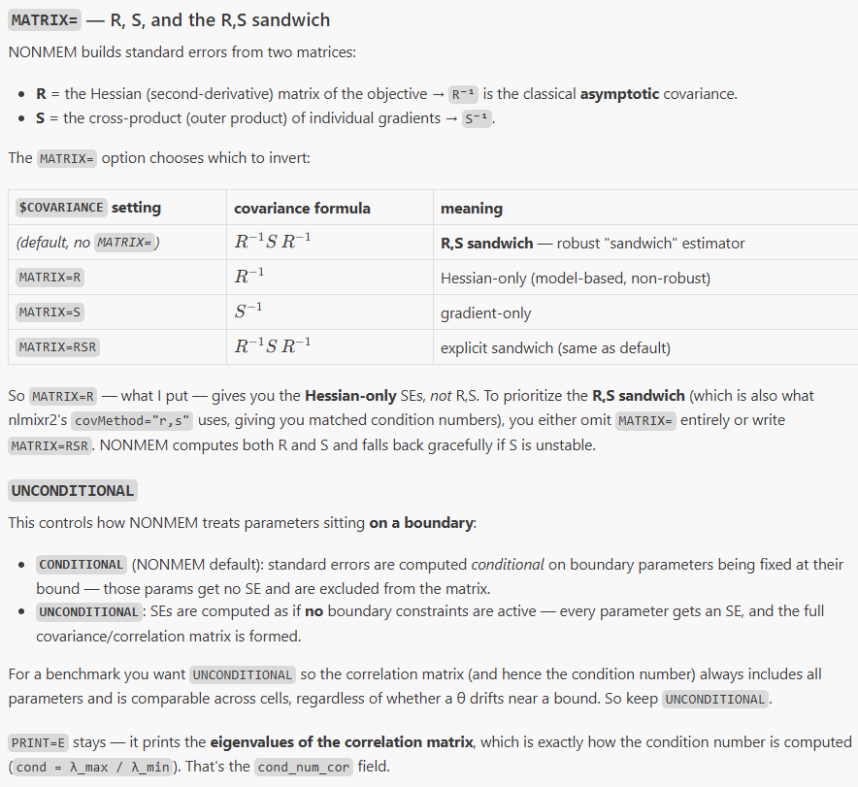
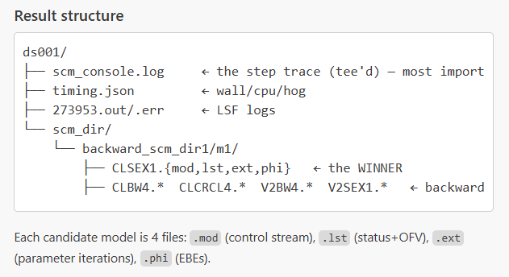
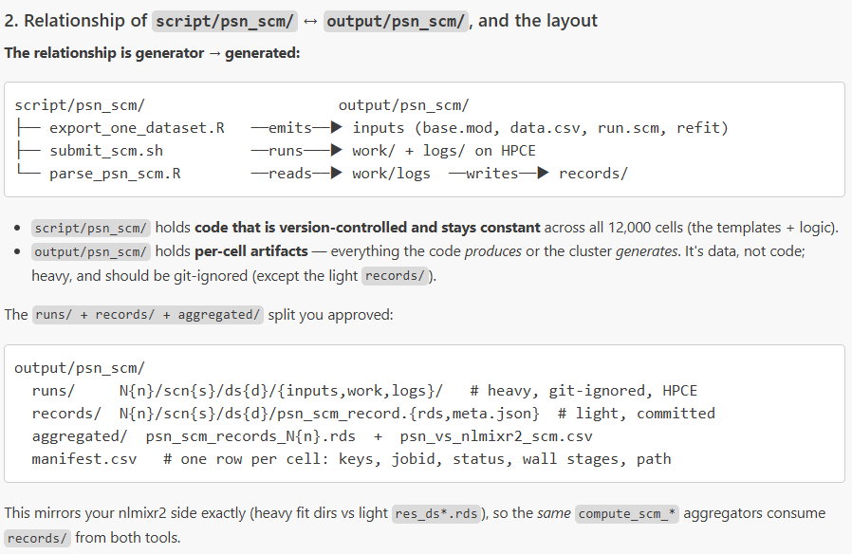
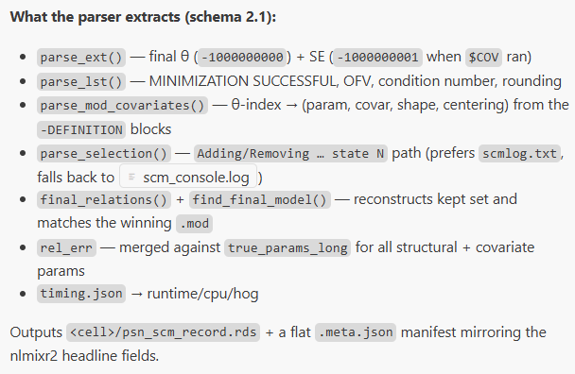
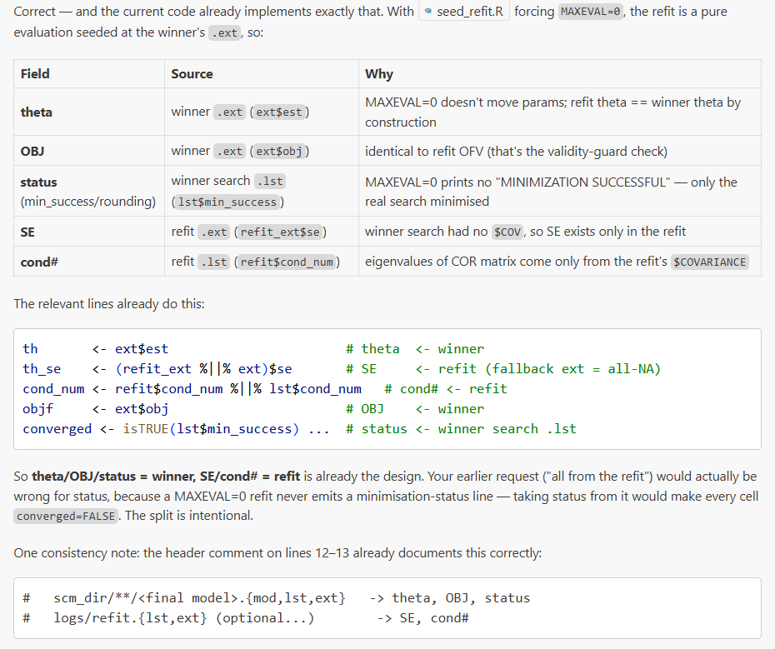

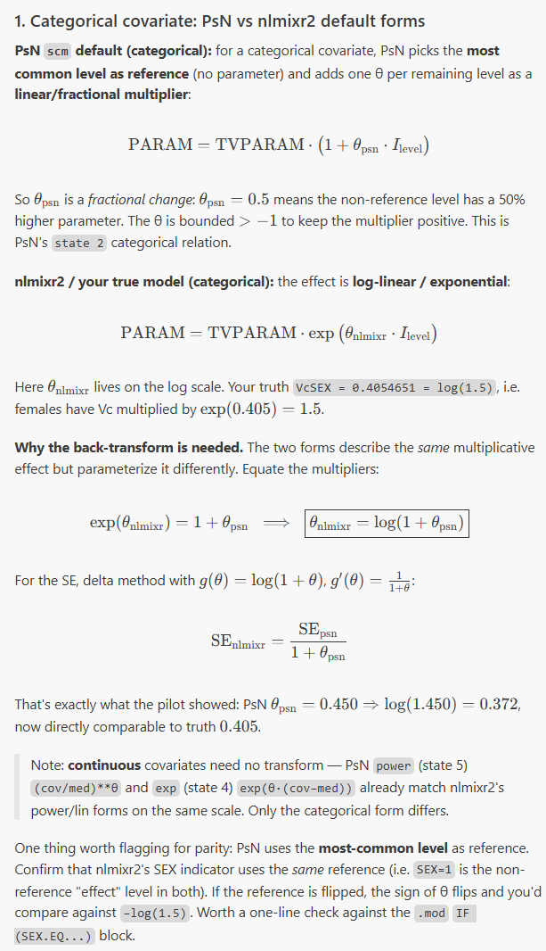
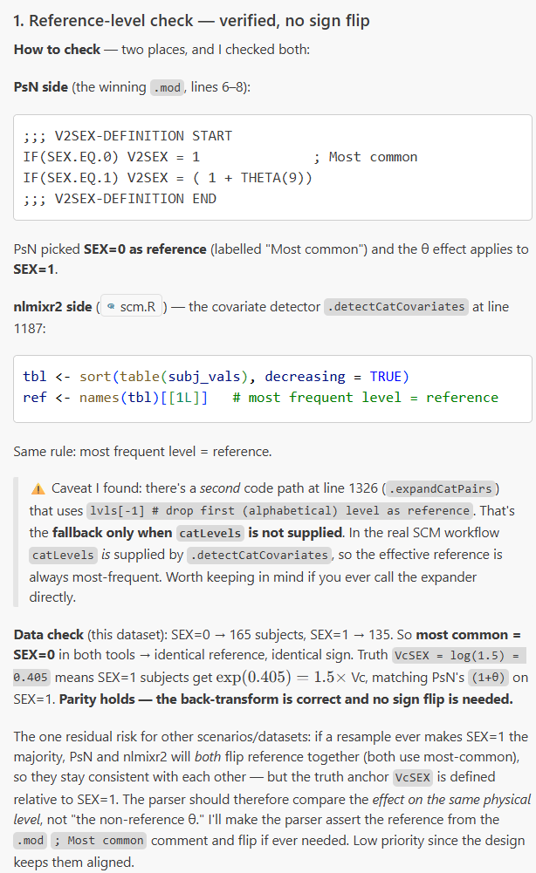

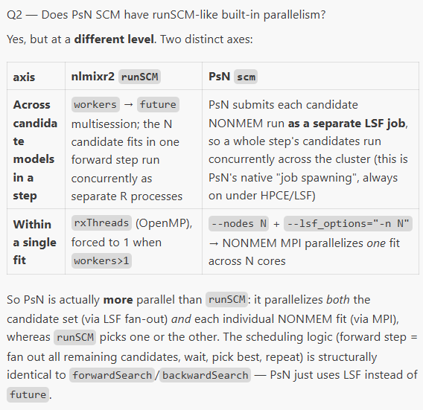
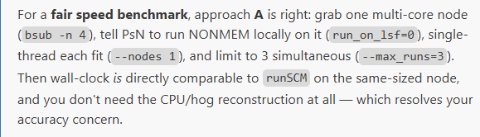

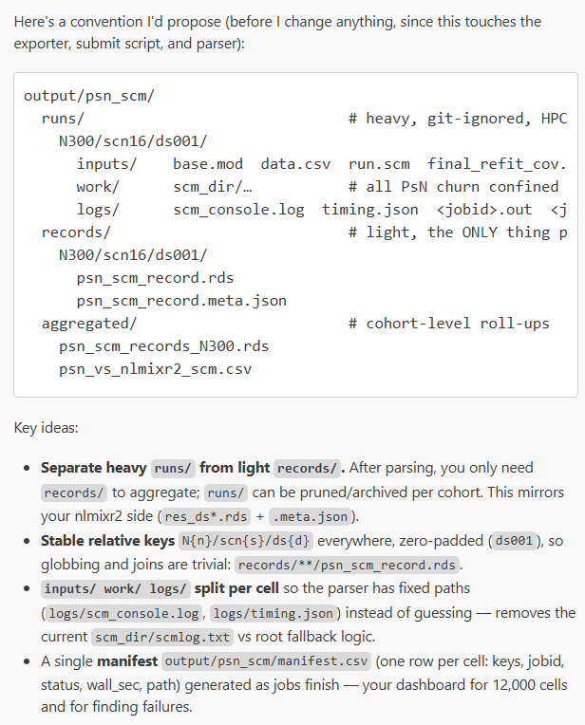
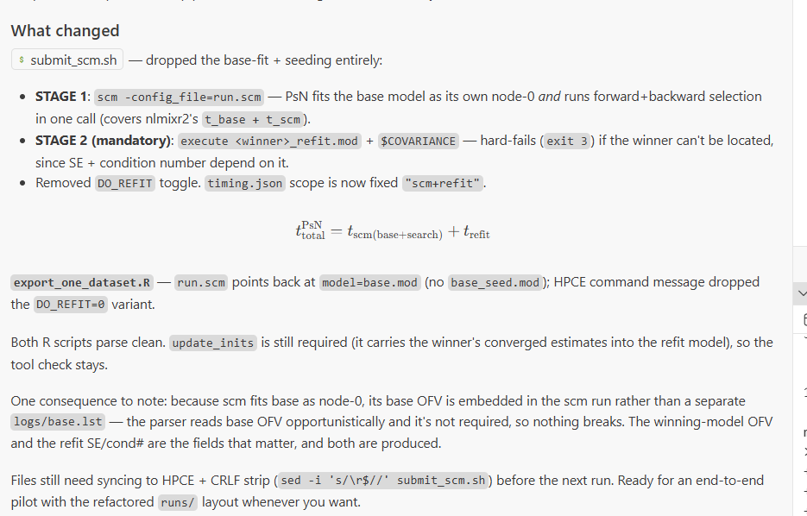

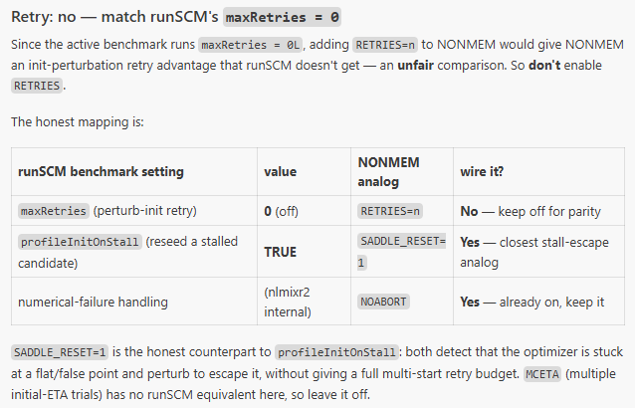

Convergence status
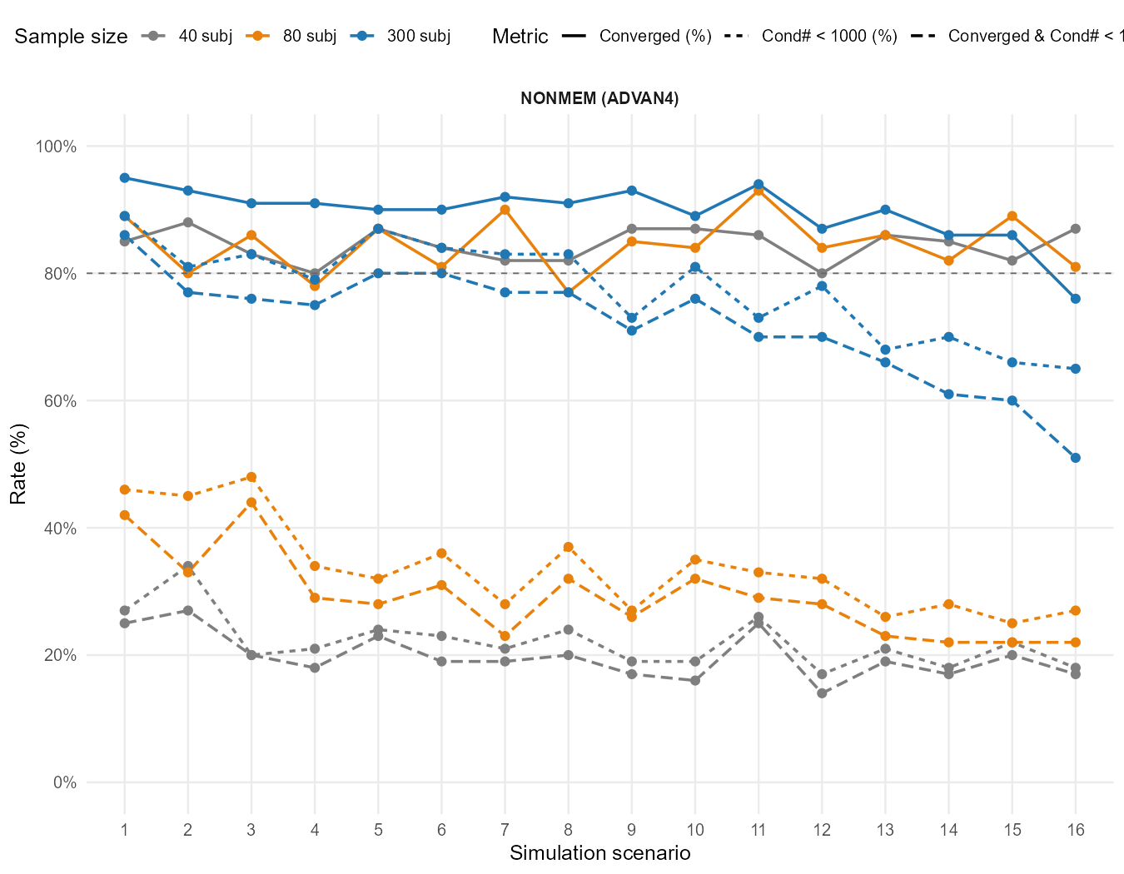

Power Curve
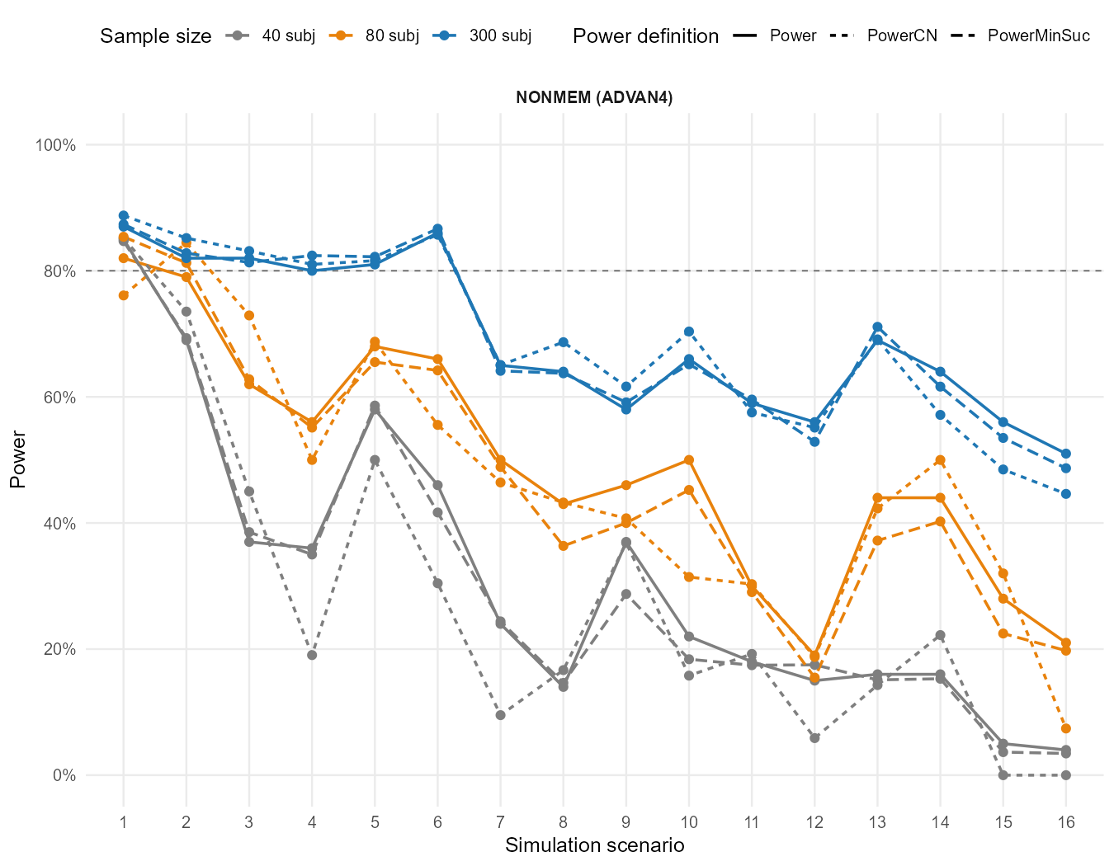

Covariate Selection Pattern
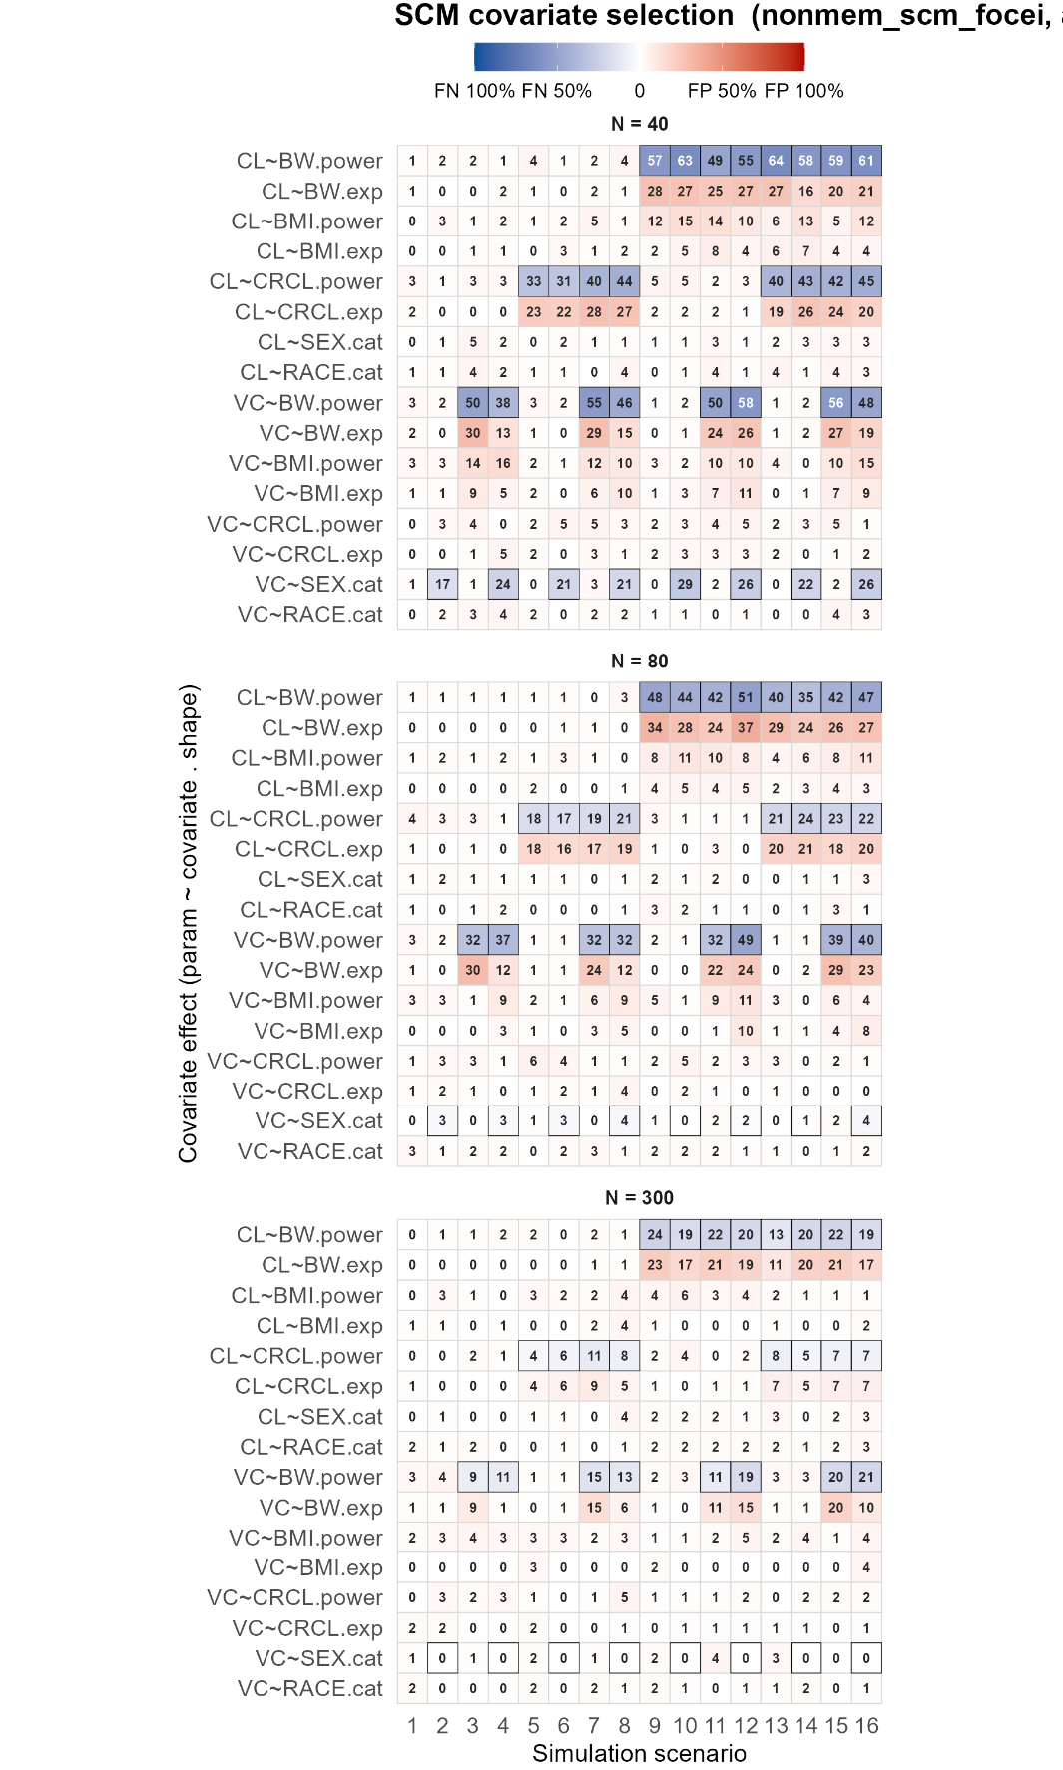

Relative Error
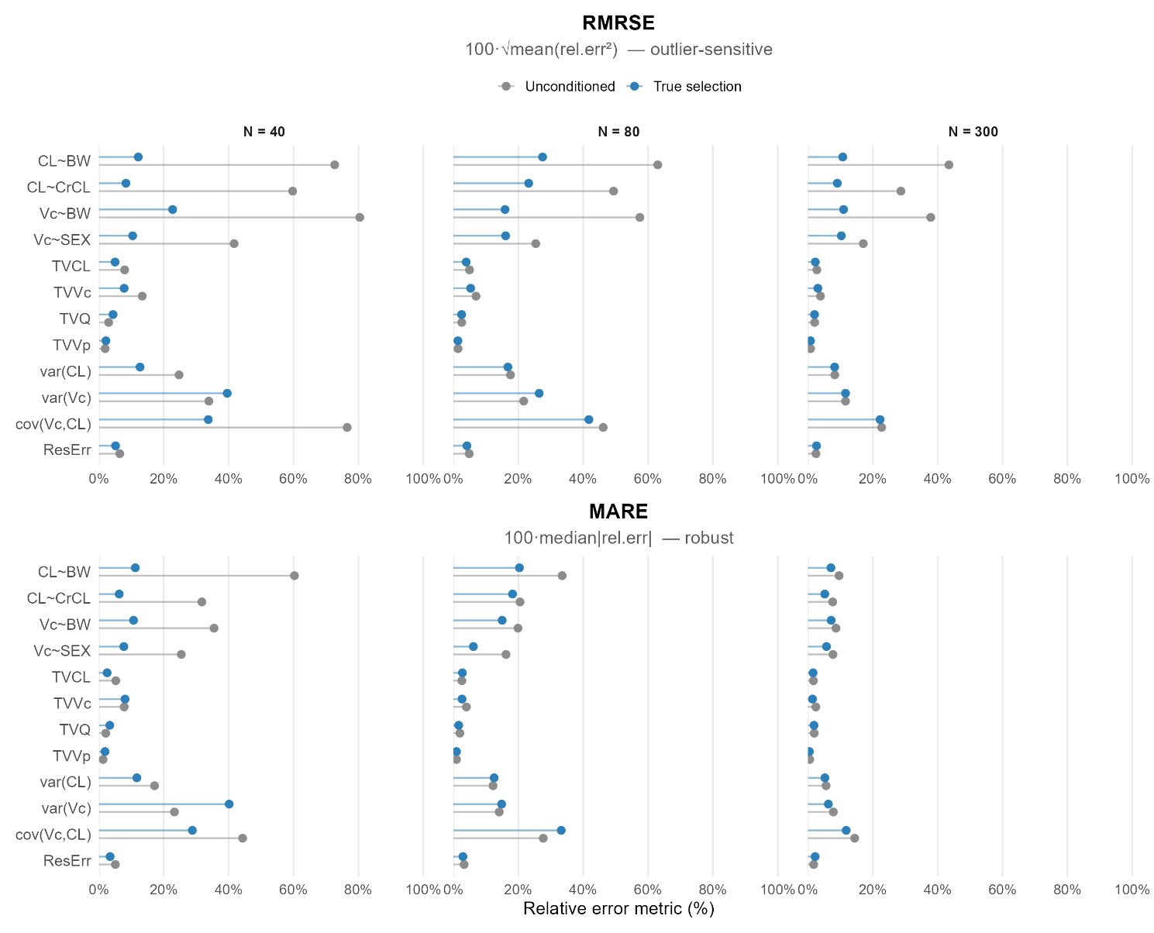
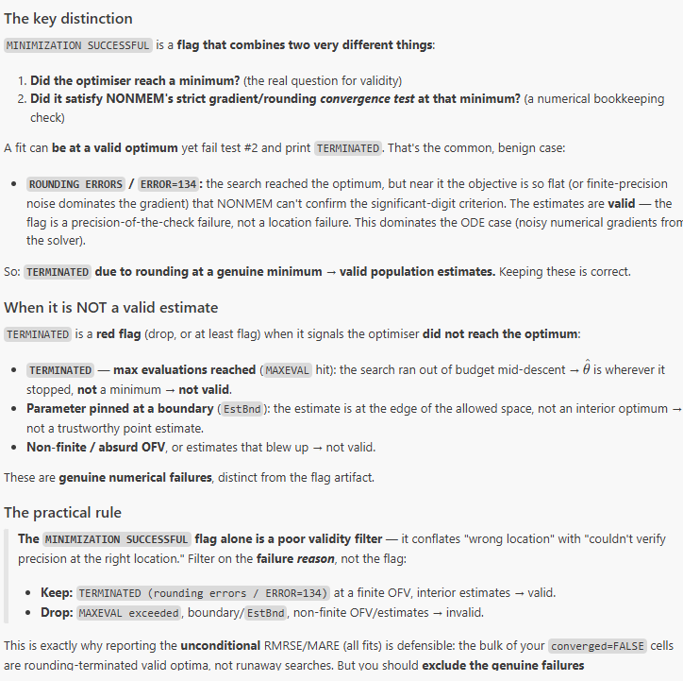
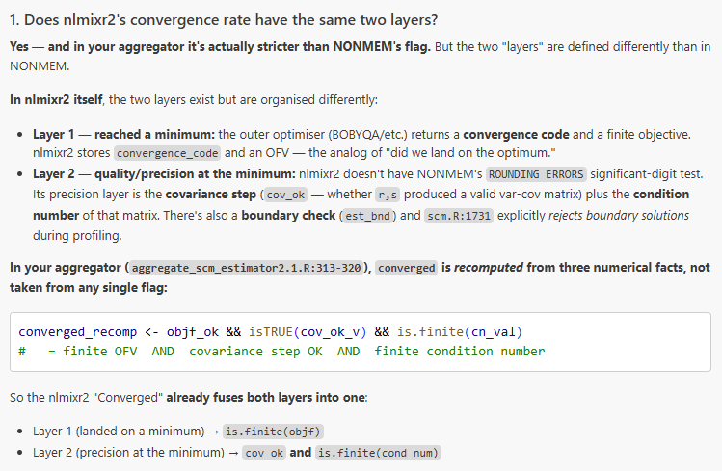

5. Parallelism in NLMIXR2
Does NONMEM offer parallelism in model fitting and/or scm?
How can we demonstrate the advantage of nlmixr2 over nonmem in speed?
For lincmt, 3 scm_workers * 2 rxthreads works
For ode, 3 scm_workers * 2 rxthreads corrupted. ----> scm_workers based on fork() can not fork the rxthread based on openMP

a. Reasons why worker>1 and rxthread>1 collapse
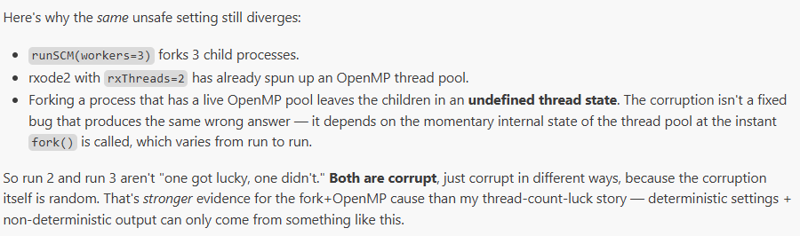
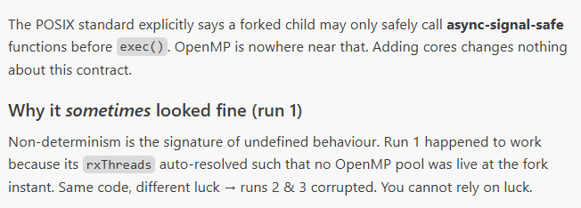
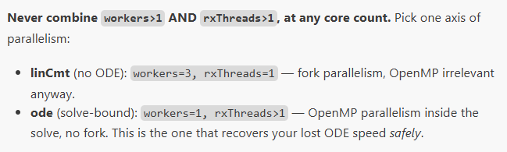
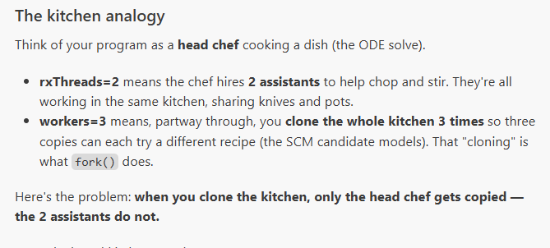
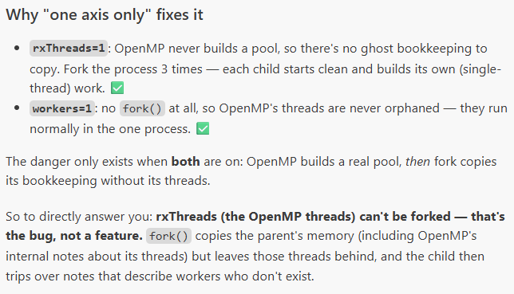
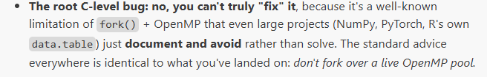

b. Wall time vs. Cpu time
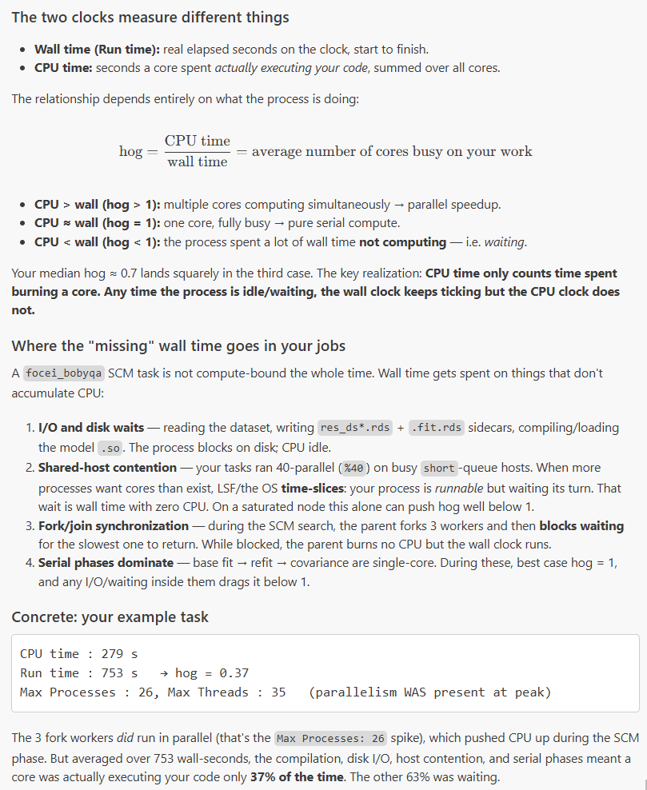
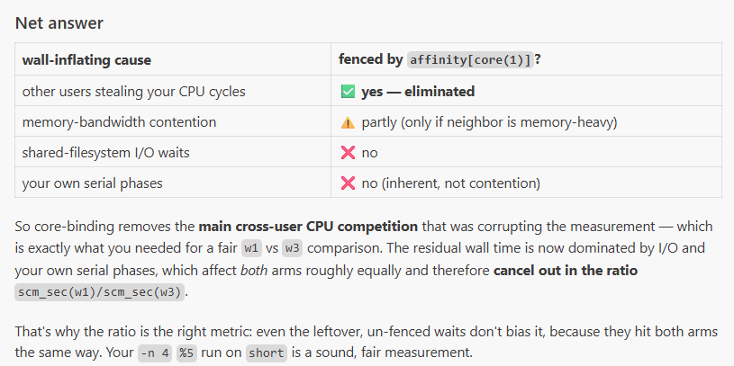
git pull && sed -i 's/\r$//' script/hpce_scm_estimator/*.sh
chmod +x script/hpce_scm_estimator/*.sh

# w3 arm — 5 datasets, 5 concurrent, core-bound automatically by the queue
WORKERS=3 RX_THREADS=1 JOBTAG=w3 OUT_ROOT=output/scm_timing_ab/w3 \
bash script/hpce_scm_estimator/submit_one_array.sh 80 16 focei bobyqa ode 5 5

# w1 arm
WORKERS=1 RX_THREADS=1 JOBTAG=w1 OUT_ROOT=output/scm_timing_ab/w1 \
bash script/hpce_scm_estimator/submit_one_array.sh 80 16 focei bobyqa ode 5 5
After both finish
Rscript script/aggregate_scm_timing.R --root output/scm_timing_ab/w1 --out_dir output/scm_timing_ab/agg_w1
Rscript script/aggregate_scm_timing.R --root output/scm_timing_ab/w3 --out_dir output/scm_timing_ab/agg_w3
# speedup = wall_scm_med(w1) / wall_scm_med(w3), per (N, structure)

NONMEM paper [-10,10]=Narrow
No boundary and 10^-5~10^5
3workers-scm; 4 threads rxode2 in local
But 3 workers-scm + 2 threds rxode2 in hpce

Impact of model parameterization; estimator/optimizer combinations on nlmixr2 fitting and scm performance

focei | lincmt/ode | Bobyba/lbfgsb3c/nlminb
vae | lincmt/ode | -
foceif | ode | lbfgsb3c/nlminb
ifoceif | ode | lbfgsb3c

lbfgsb3c – slow hiker
nlminb – reckless hiker
For lincmt, we don’t use foceif or ifoceif because the analytical gradient are turned off anyway, degrading to finite difference.

t #2 (warm-start A/B on focei_nlminb, the cell where the stall mechanism is real), or first do #1 (irlsfoceif on ODE) to confirm the analytic gradient removes the BMI blowup

Brent warm-start doesn’t work for lincmt + ifoceif+ lbfgsb3c [overshoot in to a basin]
Try this for focei+nlminb; Try ode for these analytical gradient-based method.
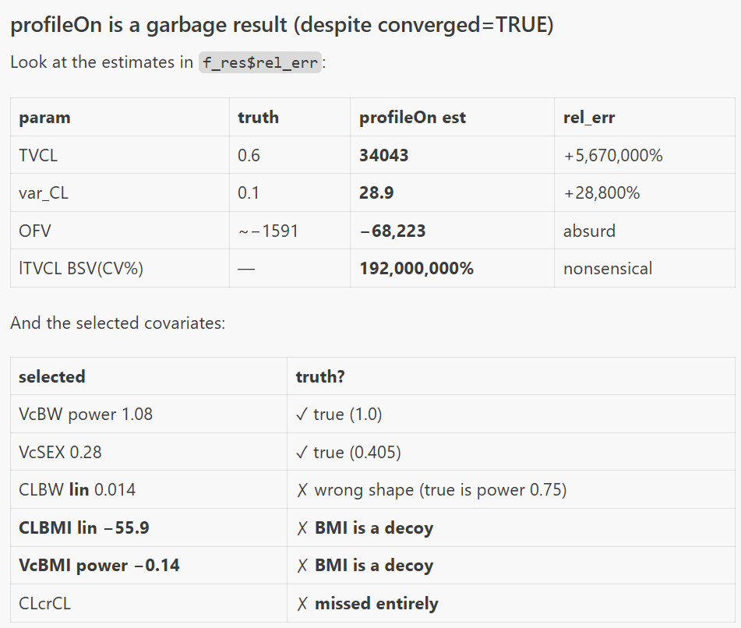

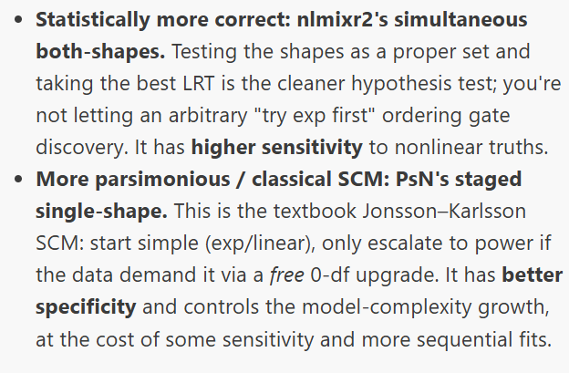Notes- VAE
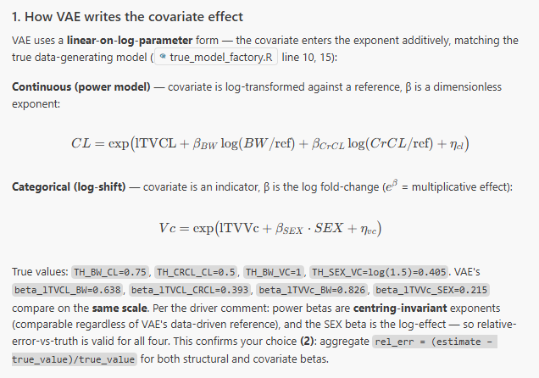
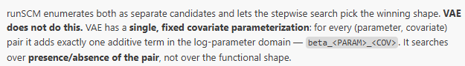
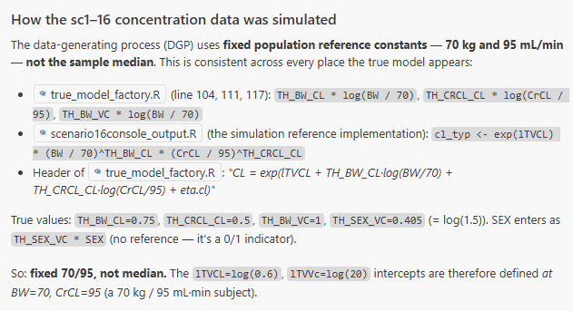
it found 24,000 res_ds*.rds files (96 cells × ~250 datasets).
fix all the eats to zero-
optim as the optimation method
Fix all the etas to zero
Fix all the theas to the right value
Do a "cheap" brent method for that parameter

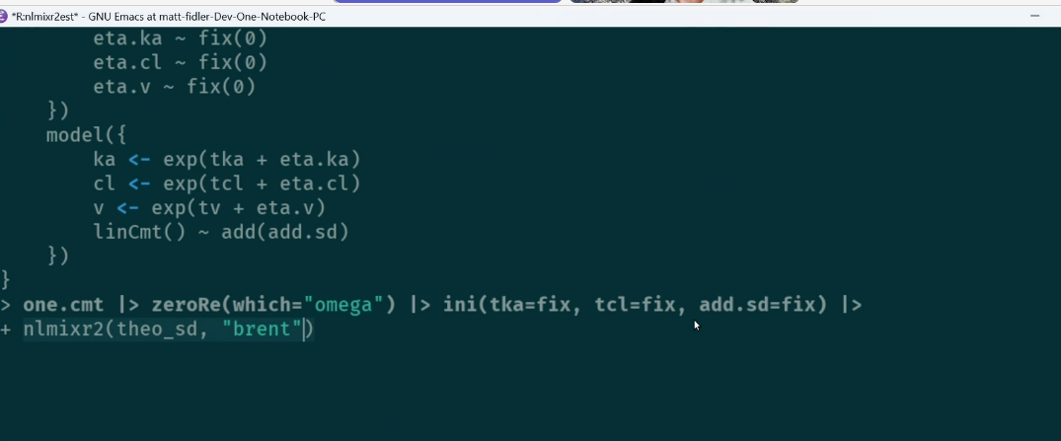
one.cmt |> zeroRe(which="omega") |> ini(tka=fix, tcl=fix, add.sd=fix, tv=c(-5, 2, 5)) |> nlmixr2(theo_sd, est="optim", optimControl(method="Brent", calcTable=FALSE, covMethod="optim"))

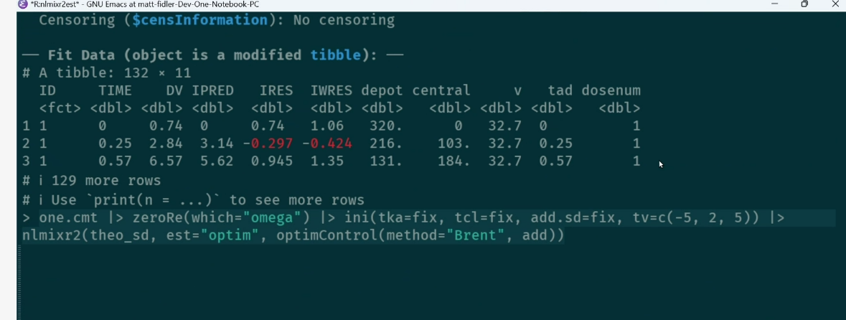



Cheap 1-D method- brent
Brent's method (named after Richard Brent, who published it in the 1970s) is an algorithm for finding the best value of a function of a single variable within a known range — for example, "somewhere between −5 and +5, which value of θ fits best?"
The process, step by step
Imagine the full model has many dials: structural parameters (clearance, volume, absorption rate), the random-effect spread (how much patients differ from each other), and the one new covariate dial we're testing.

Fix all the structural dials at the values the base model already found. We're confident about those — don't touch them.
Set all the random-effect dials to zero and lock them (that's the zeroRe in your manager's code — "zero the random effects"). This turns the messy population model into a simple, fast, single-subject-style calculation.
Leave exactly one dial free: the new covariate θ. Now the problem is trivial — we're tuning a single knob and watching one number (the fit quality) go up or down.
Turn that one knob to its best position using a cheap 1-D search (this is where "Brent" comes in — see below).
Read off the good value, unlock all the dials, plug that value in as the starting point, and hand the full model to the cell's real optimizer (nlminb or lbfgsb3c) to finish the job normally.
The key: steps 1–4 are cheap because only one thing moves and the random effects are switched off. But they hand the expensive optimizer a running start on solid ground instead of dropping it on flat ice at zero.
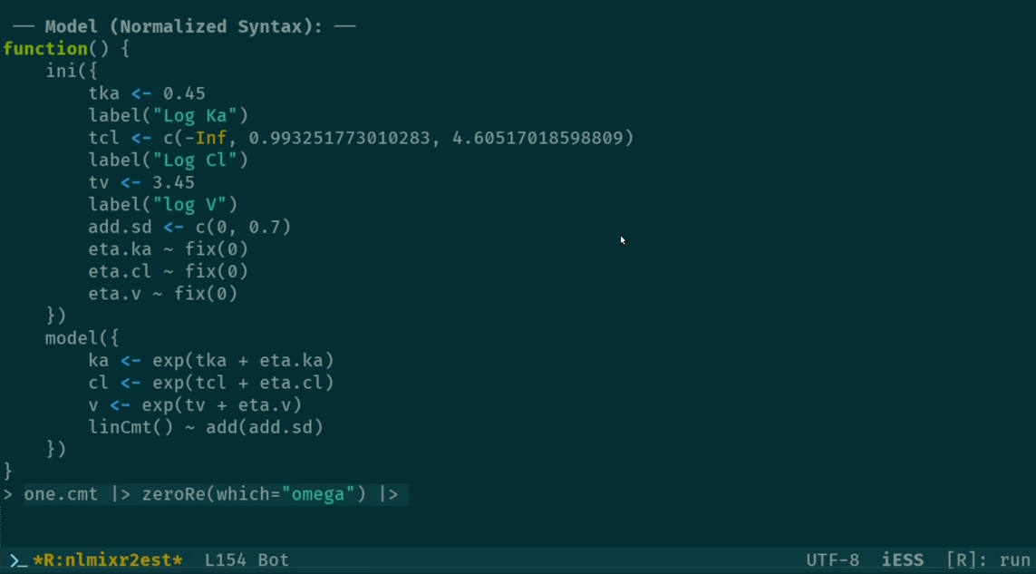

one.cmt |> zeroRe(which="omega") |> ini(tka=fix, tcl=fix, add.sd=fix, tv=c(-5, 2, 5)) |> nlmixr2(theo_sd, est="optim", optimControl(method="Brent", calcTable=FALSE, covMethod="optim"))
warm stapt using brent

close-source zrw something in the publication

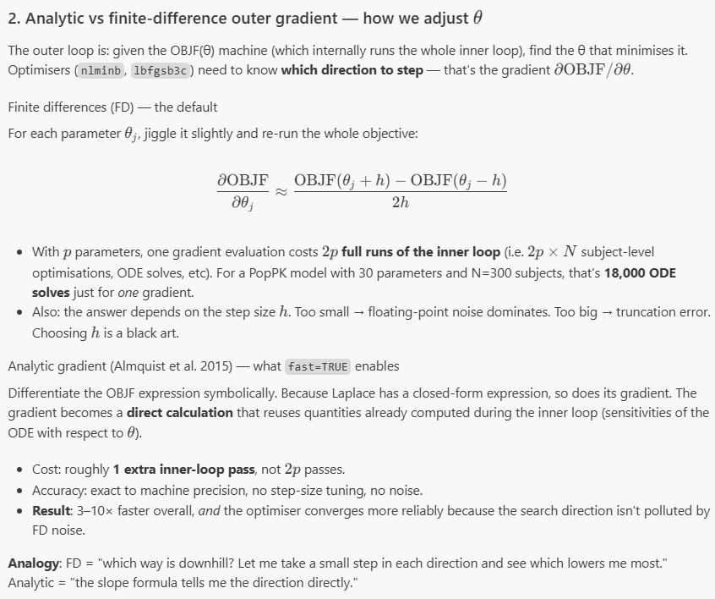
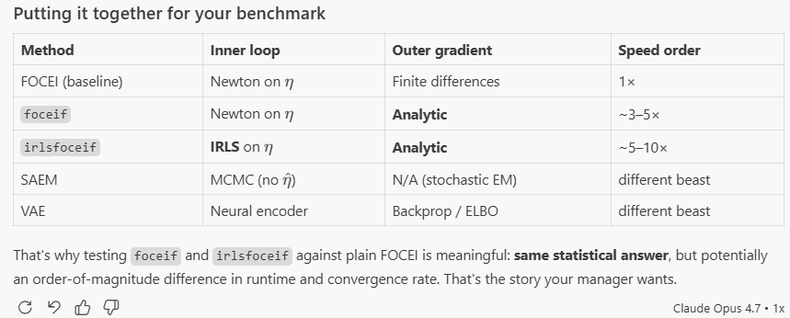
given the current hpce directory tree, first migrgate output/output_N**/output_N**_sc** to the corresponding location, which used focei/bobyba, follow the updated naming convention. Then run

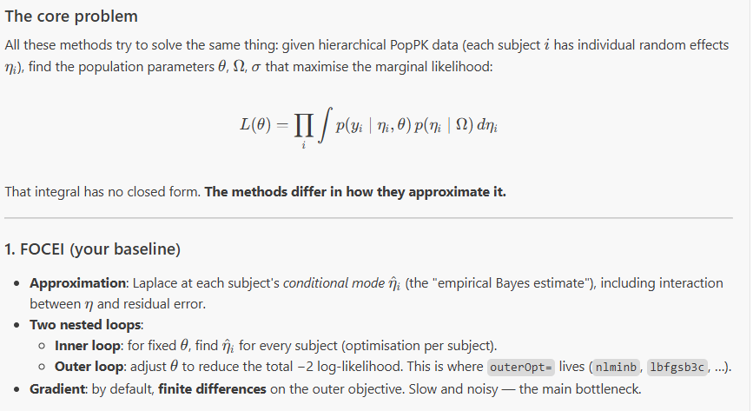

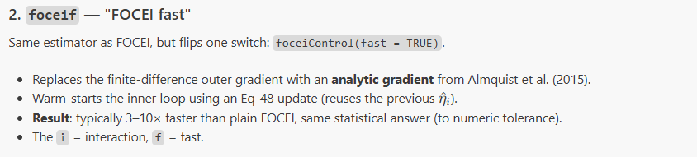
what are analytical gradient vs. finite different outer gradient? Why is it better?

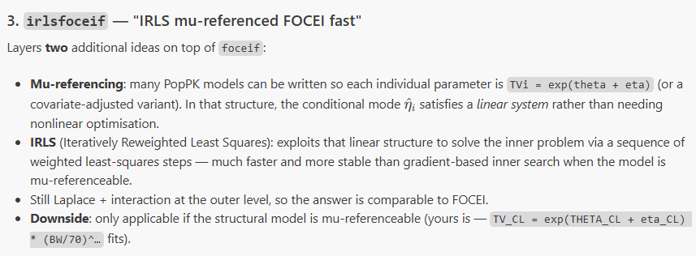
Still don’t understand IRLS. What is Laplace approximation?
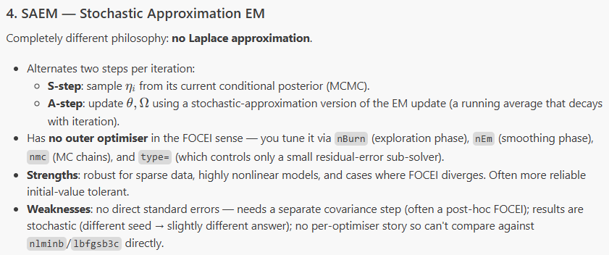

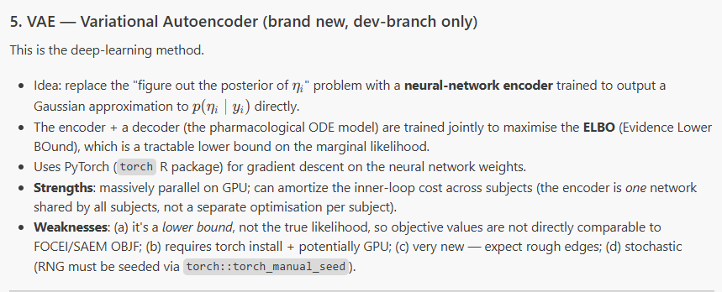
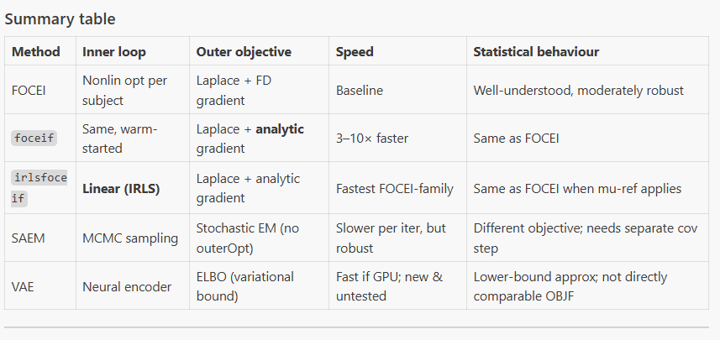

Hi Matt, I have to admit I didn't fully follow our discussion about the covariate centering, so I worked through the math on my own and then ran a few small experiments. I just wanted to share what I found and get your thoughts.

For nlmixr2scm, continuous covariates are, by default, entered in the model UI as power centering on the median. That means we can calculate the typical PK value at a fixed constant, such as 70, from the typical PK estimates centered at the median. This works mathematically, and it should work if the nlmixr2 implementation is faithful to the math.

To check whether my understanding was correct, I ran several experiments in nlmixr2scm with WT and CrCL centered on (1) 70 and 95, (2) the median, and (3) the mean. Vae only supports WT and CrCL centered on their mean. Based on those results, I think the transformation works.

That said, since you updated vae to allow user-specified centering, I’ll run it again. I think it is more friendly to user to allow them specify the center of covariates.
Hi Matt, I have to admit I didn't fully follow our discussion about the covariate centering, so I worked through the math on my own and then ran a few small experiments. I just wanted to share what I found and get your thoughts.

For nlmixr2scm, continuous covariates are, by default, entered in the model UI as power centering on the median. That means we can calculate the typical PK value at a fixed constant, such as 70, from the typical PK estimates centered at the median. This works mathematically, and it should work if the nlmixr2 implementation is faithful to the math.

To check whether my understanding was correct, I ran several experiments in nlmixr2scm with WT and CrCL centered on (1) 70 and 95, (2) the median, and (3) the mean. Vae only supports WT and CrCL centered on their mean. Based on those results, I think the transformation works.

That said, since you updated vae to allow user-specified centering, I’ll run it again. I think it is more friendly to user to allow them specify the center of covariates.

Powershape ONLY

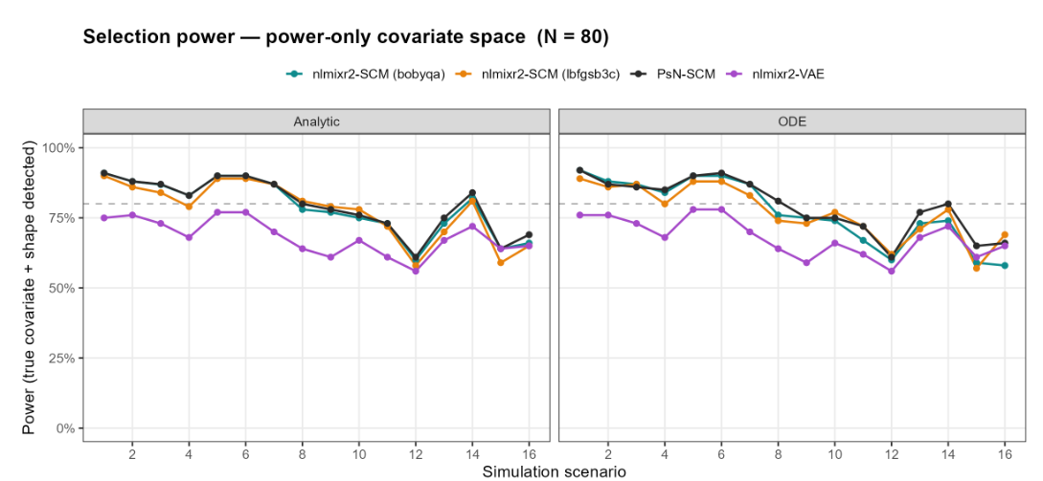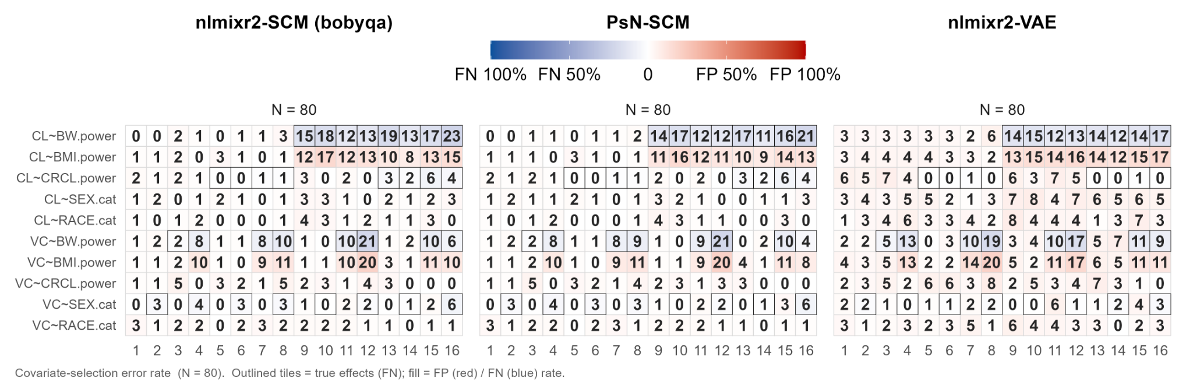

Warmup on-off + competing shape
